Academic Program Review
ACADEMIC YEAR | 2013 -2014 | Basic Skills X Transfer Career Technical Education (CTE)
PROGRAM | Humanities (Includes Philosophy, Humanities, Religious Studies, and Theatre Arts courses)
DEPARTMENT | Humanities
DIVISION | Arts, Letters, and Learning Services
SUBMITTER | Aaron S. Edwards, Carol Hegarty

I. INSTITUTIONAL GOALS

INSTITUTIONAL GOAL  1 | INSTITUTIONAL MISSION AND EFFECTIVENESS – The College will maintain programs and services that focus on the mission of the College supported by data-driven assessments to measure student learning and student success.
INSTITUTIONAL GOAL  2 | STUDENT LEARNING PROGRAMS AND SERVICES – The College will maintain instructional programs and services which support student success and the attainment of student educational goals.
INSTITUTIONAL GOAL  3 | RESOURCES – The College will develop and manage human, technological, physical, and financial resources to effectively support the College mission and the campus learning environment.
INSTITUTIONAL GOAL  4 | LEADERSHIP AND GOVERNANCE – The Board of Trustees and the Superintendent/President will establish policies that assure the quality, integrity, and effectiveness of student learning programs and services, and the financial stability of the institution.

II. PROGRAM GOALS

- PAST – EVALUATION OF PREVIOUS CYCLE OBJECTIVES/PROGRAM GOALS (SET IN PREVIOUS YEAR) List your previous objectives/goals and associated Institutional Goals. All program goals must address at least one of the institutional goals.

PAST PROGRAM GOALS  (Describe past program goals.) |  |  |  |  | INSTITUTIONAL  GOAL(S)  (Check all that apply.)
1 | PAST PROGRAM GOAL #1 |  |  |  | INSTITUTIONAL GOAL(S)
1 | Identify Program Goal from Last Program Review: Increase online and alternative delivery opportunities for Humanities courses.  Religious Studies 100 is currently only offered as a face-to-face course, but was taught online as well. The instructor would like to teach REL 100 online as soon as it can be re-approved by the Distance Ed Committee.  MUS 102 was offered online in the past and the instructor would like to offer it again on Blackboard.  Art history courses were offered online and one art history faculty member would like to offer ART 100 online. She has taken one of the two necessary courses for online approval and has most of the materials ready.  In summation, online courses in art history, philosophy, languages, and religious studies need to be created and considered for the approval process. |  |  |  | 1X  2X  3X  4
1 | Met |  | Partially Met | Not Met X | 1X  2X  3X  4
1 | Provide detail on any improvements/effectiveness and detail status on those not fully met: In 2012 the Distance Education program underwent significant changes. One of the results of the changes was that all online classes were suspended until certain institutional measures were met. There were many Distance Educational personnel changes in the last two years. There have been four Distance Ed. Coordinators in the last couple of years. Also a pre-requisite of taking two online pedagogical classes was instated for each instructor who would like to teach online. Aaron Edwards, philosophy instructor, has taken and passed both classes and am in the process of having the new Distance Education coordinator approve the course he created. In the last couple of years online classes have been almost non-existent for students but hopefully this will change in the future. With so many working students at Imperial Valley College, the demand for online classes has been very high since he has been teaching at Imperial Valley College.  Religious Studies 100 is currently only offered as a face-to-face course, but was taught online as well. The instructor would like to teach REL 100 online as soon as it can be re-approved by the Distance Ed Committee.  MUS102 was offered online in the past and the instructor would like to offer it again on Blackboard.  Art history courses were offered online and one art history faculty member would like to offer ART 100 online. She has taken one of the two necessary courses for online approval and has most of the materials ready.  In summation, online courses in art history, philosophy, languages, and religious studies need to be created and considered for the approval process. |  |  |  | 1X  2X  3X  4

2 | PAST PROGRAM GOAL #2 |  |  | INSTITUTIONAL GOAL(S)
2 | Identify Program Goal from Last Program Review: Start a Philosophy club to keep students engaged in religious, ethical and political issues. |  |  | 1  2X  3X  4
2 | Met X | Partially Met | Not Met | 1  2X  3X  4
2 | Provide detail on any improvements/effectiveness and detail status on those not fully met: |  |  | 1  2X  3X  4
3 | PAST PROGRAM GOAL #3 |  |  | INSTITUTIONAL GOAL(S)
3 | Identify Program Goal from Last Program Review: Improve student success rate through: SLO performance analysis and curriculum revision, as appropriate, definition of course prerequisites if appropriate. |  |  | 1X  2X  3  4
3 | Met X | Partially Met | Not Met | 1X  2X  3  4
3 | Provide detail on any improvements/effectiveness and detail status on those not fully met: Success Rates for both Philosophy and Religious Studies is up 43% from Spring 2011 to Spring 2013. Philosophy Instructor Aaron Edwards is very happy with these results. This does not mean that the work is done but the program is on the right track. |  |  | 1X  2X  3  4

Comments:

- PRESENT – DATA ANALYSIS AND PROGRAM HEALTH

- Summarize and analyze all disaggregated data by day, evening, gender, ethnicity, and distance education regarding enrollments, fill rates, productivity, completion, success, retention, persistence, and transfer (complete a, b, & c). Attach graphs or trend data.

- Discuss and chart the trends in enrollment and fill rate for each program by day and evening at the program level.

Philosophy: Enrollment figures have consistently dropped over the past three years in both fall and spring semesters The decrease in students may have been due to the economy and some other factors. Enrollments are slightly higher in spring semesters, going against the trend for most programs. There were also fewer sections offered in Fall 2012 and Spring 2013 but this was due to Ethics being doubled filled with a capacity of 80 students and losing Distance Education courses. The amount of sections being offered has slightly decreased but this is due to losing one of our adjunct instructors and being part of the IVUP program in Spring of 2013. Fill-rate has been consistent at 90-95%, close to the campus wide average.

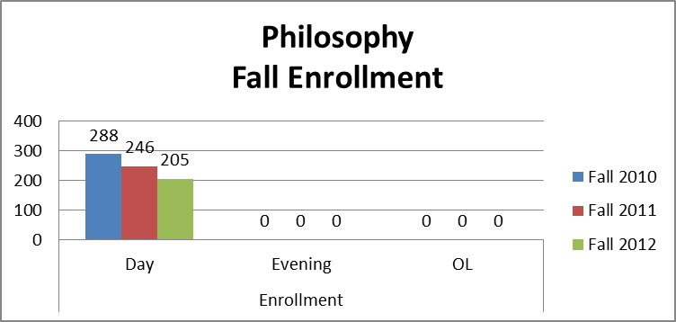

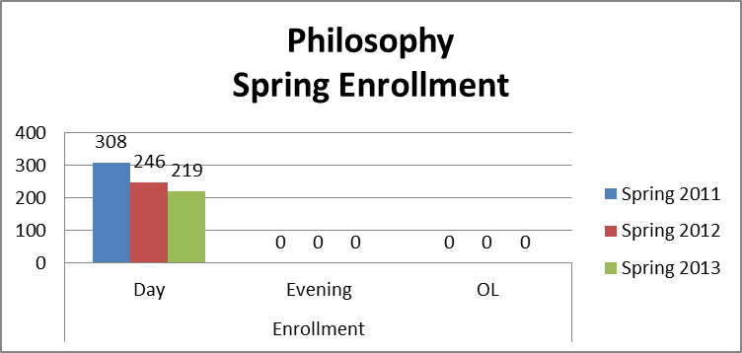

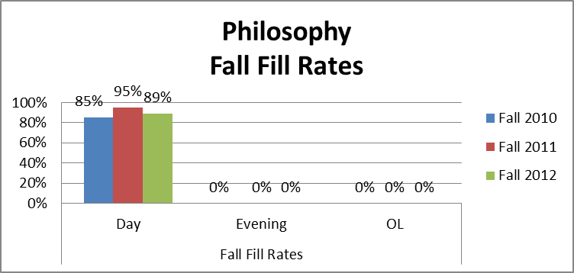
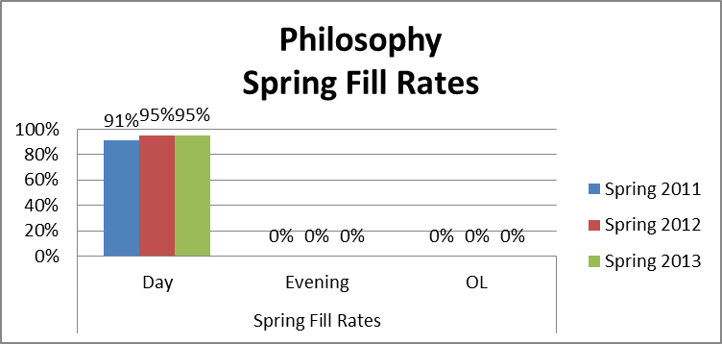

Term | Enroll | Fill | Sections
Fall 2010 | 288 | 85% | 9
Fall 2011 | 246 | 95% | 7
Fall 2012 | 205 | 89% | 6
Spring 2011 | 308 | 91% | 9
Spring 2012 | 246 | 95% | 7
Spring 2013 | 219 | 95% | 5
% Change from Fall 2010 to Fall 2012 | -29% | 5% | -33%
% Change from Spring 2011 to Spring 2013 | -29% | 4% | -44%

Religious Studies: Religious Studies courses’ enrollments and fill rates have dropped and then risen. One night section has been offered, and prior to the hiatus for online classes, IVC offered an online class. (This writer questions the data supplied below which indicates online classes). Every section was filled to at least 83% capacity

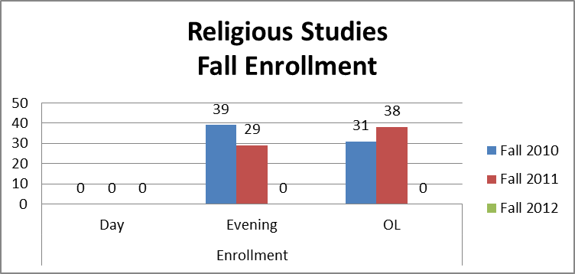
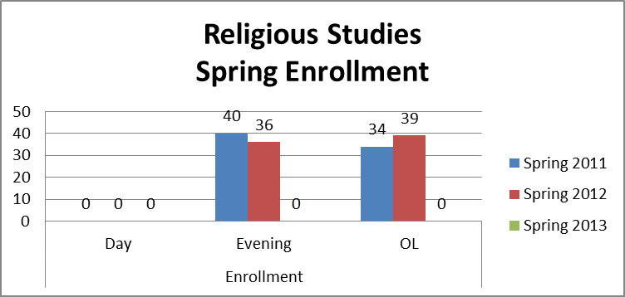

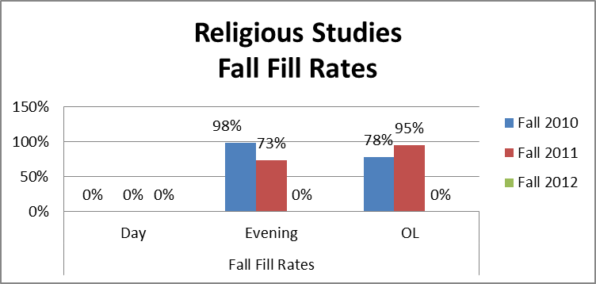
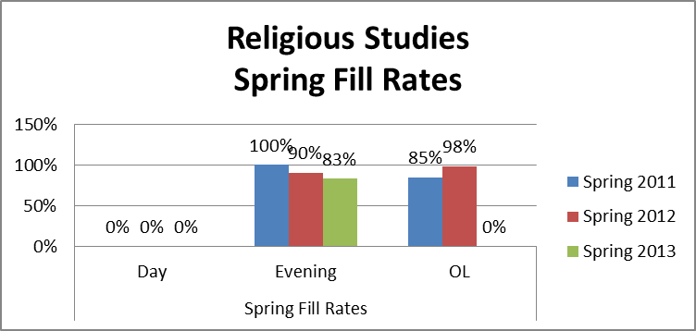

Term | Program | Day Sections | Day Fill | Day Enroll | Day Mass Cap | Ex Day Sections | Ex Day Fill | EX Day Enroll | EX Day Mass Cap | Online Sections | Online Fill | Online Enroll | Online Mass Cap
Fall 2010 | RELS | 0 | 0% | 0 | 0 | 1 | 98% | 39 | 40 | 1 | 78% | 31 | 40
Fall 2011 | RELS | 0 | 0% | 0 | 0 | 1 | 73% | 29 | 40 | 1 | 95% | 38 | 40
Fall 2012 | RELS | 0 | 0% | 0 | 0 | 0 | 0% | 0 | 0 | 0 | 0% | 0 | 0
Spring 2011 | RELS | 0 | 0% | 0 | 0 | 1 | 100% | 40 | 40 | 1 | 85% | 34 | 40
Spring 2012 | RELS | 0 | 0% | 0 | 0 | 1 | 90% | 36 | 40 | 1 | 98% | 39 | 40
Spring 2013 | RELS | 0 | 0% | 0 | 0 | 1 | 83% | 33 | 40 | 0 | 0% | 0 | 0
Average | RELS | 0.0 | #DIV/0! | 0.0 | 0.0 | 0.8 | 88.8% | 29.5 | 33.3 | 0.7 | 89.0% | 23.7 | 26.7
Fall '10 - '12 Change |  | #DIV/0! | #DIV/0! | ###### | #DIV/0! | 0% | 0% | 0% | 0% | 0% | 0% | 0% | 0%
Spring '11 - '13 Change |  | #DIV/0! | #DIV/0! | ###### | #DIV/0! | 100% | 137% | 138% | 100% | 100% | 89% | 89% | 100%

Humanities
HUM 100, Introduction to Humanities, and HUM 226, Introduction to Mythology (which was offered in Fall 2010 and 2012, and Spring 2013) have good fill rates, from 90% to 113%. There was only one section, HUM 226 in Fall 2010, which was offered as an extended day class.

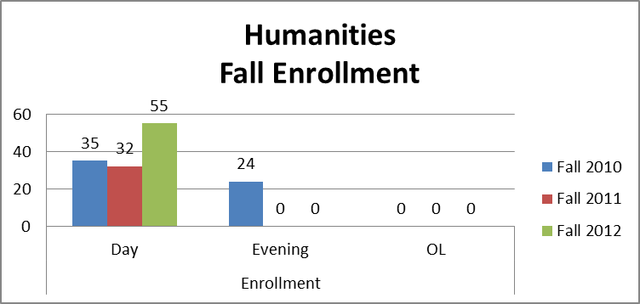

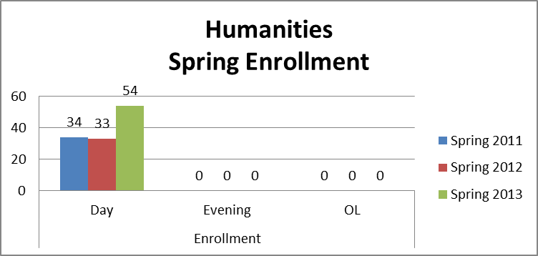
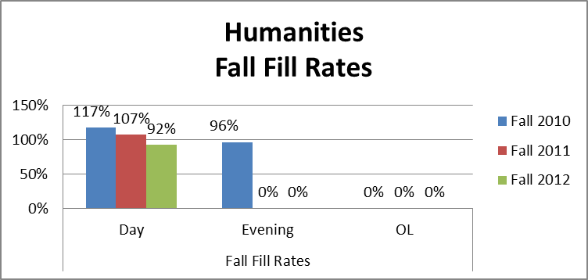

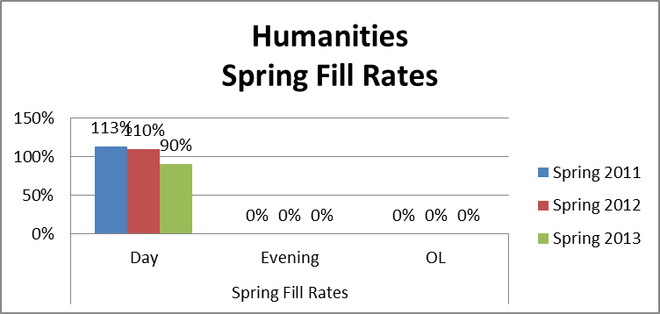

Term | Program | Day Sections | Day Fill | Day Enroll | Day Mass Cap | Ex Day Sections | Ex Day Fill | EX Day Enroll | EX Day Mass Cap | Online Sections | Online Fill | Online Enroll | Online Mass Cap
Fall 2010 | HUM | 1 | 117% | 35 | 30 | 1 | 96% | 24 | 25 | 0 | 0% | 0 | 0
Fall 2011 | HUM | 1 | 107% | 32 | 30 | 0 | 0% | 0 | 0 | 0 | 0% | 0 | 0
Fall 2012 | HUM | 2 | 92% | 55 | 60 | 0 | 0% | 0 | 0 | 0 | 0% | 0 | 0
Spring 2011 | HUM | 1 | 113% | 34 | 30 | 0 | 0% | 0 | 0 | 0 | 0% | 0 | 0
Spring 2012 | HUM | 1 | 110% | 33 | 30 | 0 | 0% | 0 | 0 | 0 | 0% | 0 | 0
Spring 2013 | HUM | 2 | 90% | 54 | 60 | 0 | 0% | 0 | 0 | 0 | 0% | 0 | 0
Average | HUM | 1.3 | 101% | 40.5 | 40.0 | 0.2 | 96.0% | 4.0 | 4.2 | 0.0 | #DIV/0! | 0.0 | 0.0
Fall '10 - '12 Change |  | 200% | 79% | 157% | 200% | 0% | 0% | 0% | 0% | #DIV/0! | #DIV/0! | #DIV/0! | #DIV/0!
Spring '11 - '13 Change |  | 100% | 106% | 106% | 100% | #DIV/0! | #DIV/0! | #DIV/0! | #DIV/0! | #DIV/0! | #DIV/0! | #DIV/0! | #DIV/0!

Theatre Arts
THEA 100, Fundamentals of Acting, and THEA 120, Introduction to Theatre, are offered sporadically when the qualified full time instructors accept teaching it as overload. IVC no longer has a qualified part time theater instructor.

The table below shows fill rates of 120% and 156% for THEA 100 which has a cap of 25 students. Since the two classes successfully included 30 or more students, raising the cap for this class is a possibility, see also WSCH/FTEF discussion in C.1.b. below.

THEA 120, on the other hand, has a cap of 40, and was not offered in this particular time period. The instructor who is currently teaching THEA 120, Spring 2014, expressed dismay at the high cap, saying it was too high to provide quality instruction, and may choose to not teach it again because of this.

Theatre Arts
Term | Enroll | Fill | Sections | Mass Cap | Avg Class Cap | Avg Class Size | FTES | FTEF | WSCH/FTEF | Success | Retention | Day Classes | Extended Day Classes | Online Classes
Fall 2010 | 30 | 120% | 1 | 25 | 25 | 30 | 3.11 | 0.2 | 510 | 77% | 77% | 1 | 0 | 0
Spring 2011 | 39 | 156% | 1 | 25 | 25 | 39 | 4.04 | 0.2 | 663 | 74% | 90% | 1 | 0 | 0
% Change from Fall 2010 to Fall 2012 | NA | NA | NA | NA | NA | NA | NA | NA | NA | NA | NA | NA | NA | NA
% Change from Spring 2011 to Spring 2013 | NA | NA | NA | NA | NA | NA | NA | NA | NA | NA | NA | NA | NA | NA

- What are the trends in productivity? (WSCH/FTEF) The goal is 525 as per state guidelines. A low number means that we are below target levels for productivity. For example, in a small class that has a mandated cap of 15 students, the fill rate may be 100% but the productivity number (WSCH/FTEF) will be very low. A class with a cap of 40 students with a 100% fill rate will have a productivity number close to or above 525.
Philosophy: Productivity has been at a steady climb. This is partially due to the number of sections being reduced from nine in 2010 to seven in 2012. The main factor to productivity being so high is that most Philosophy courses have a high cap and they stay close to that cap for most of the semester. The productivity should stay close to what it has been (in the high five hundreds) if online classes resume.

Term WSCH/FTEF
Fall 2010 | 544
Fall 2011 | 597.43
Fall 2012 | 580.83
Spring 2011 | 581.78
Spring 2012 | 597.43
Spring 2013 | 608.6
% Change from Fall 2010 to Fall 2012 | 7%
% Change from Spring 2011 to Spring 2013 | 5%

Religious Studies:
Religious Studies has a cap of forty for each course. Productivity for Religious studies courses is higher than the average for a class that has a cap of forty. The productivity has fluctuated slightly hitting is highest point in Spring of 2012 and its lowest in Spring of 2013.

Term WSCH/FTEF
Fall 2010 | 595
Fall 2011 | 569.5
Spring 2011 | 629
Spring 2012 | 637.5
Spring 2013 | 561
% Change from Fall 2010 to Fall 2011 | -4%
% Change from Spring 2011 to Spring 2013 | -11%

Humanities:

HUM 100, Introduction to Humanities, achieves over the 525 WSCH/FTEF state guideline for productivity except when the data is mixed with that of HUM 226, Introduction to Mythology, which has issues making enrollment. For example, the two courses generated only approximately 467.5 WSCH/FTEF, as shown in Fall 2012 below, whereas HUM 100 generates 544 or more on its own, as in Fall 2011. To more closely achieve the 525 WSCH/FTEF state guideline figure, these courses need more than a 100% fill rate. Fill rates for HUM 100 range between 92% to as high as 113% for Spring 2011. For example, for Fall 2011, 32 students generated a WSCH/FTEF figure of 544. Success was 97% and retention was 100%.

 |  |  |  |  | Humanities
Term | Enroll | Fill | Sec-  tions | Mass Cap | Avg Class Cap | Avg Class Size | FTES | FTEF | WSCH/  FTEF | Suc-cess | Reten-  tion | Day Classes | Exten-ded Day Classes | Online Classes
Fall 2010 | 59 | 107% | 2 | 55 | 27.5 | 29.5 | 6.12 | 0.4 | 501.5 | 63% | 71% | 1 | 1 | 0
Fall 2011 | 32 | 107% | 1 | 30 | 30 | 32 | 3.32 | 0.2 | 544 | 97% | 100% | 1 | 0 | 0
Fall 2012 | 55 | 92% | 2 | 60 | 30 | 27.5 | 5.7 | 0.4 | 467.5 | 53% | 71% | 2 | 0 | 0
Spring 2011 | 34 | 113% | 1 | 30 | 30 | 34 | 3.52 | 0.2 | 578 | 79% | 94% | 1 | 0 | 0
Spring 2012 | 33 | 110% | 1 | 30 | 30 | 33 | 3.42 | 0.2 | 561 | 94% | 100% | 1 | 0 | 0
Spring 2013 | 54 | 90% | 2 | 60 | 30 | 27 | 5.6 | 0.4 | 459 | 69% | 83% | 2 | 0 | 0
% Change from Fall 2010 to Fall 2012 | -7% | -14% | 0% | 9% | 9% | -7% | -7% | 0% | -7% | -16% | 0% | 100% | -100% | NA
% Change from Spring 2011 to Spring 2013 | 59% | -20% | 100% | 100% | 0% | -21% | 59% | 100% | -21% | -14% | -11% | 100% | NA | NA

Theatre Arts
THEA 100, which is included in the data below, has a cap of 25. In Fall 2010, with a fill rate of 120%, 510 WSCH/FTEF was generated which is about 97% of the state guideline of 525. This means that the course is not quite productive and may need to have a slightly higher cap to be financially viable.
Theatre Arts
Term | Enroll | Fill | Sec  tions | Mass Cap | Avg Class Cap | Avg Class Size | FTES | FTEF | WSCH/  FTEF | Suc  cess | Reten  tion | Day Clas  ses | Exten  ded Day Classes | Online Classes
Fall 2010 | 30 | 120% | 1 | 25 | 25 | 30 | 3.11 | 0.2 | 510 | 77% | 77% | 1 | 0 | 0
Spring 2011 | 39 | 156% | 1 | 25 | 25 | 39 | 4.04 | 0.2 | 663 | 74% | 90% | 1 | 0 | 0
% Change from Fall 2010 to Fall 2012 | NA | NA | NA | NA | NA | NA | NA | NA | NA | NA | NA | NA | NA | NA
% Change from Spring 2011 to Spring 2013 | NA | NA | NA | NA | NA | NA | NA | NA | NA | NA | NA | NA | NA | NA

- Discuss and chart the success and retention rates by day, evening (extended day), and online classes in each program and identify gaps.
Philosophy: The success rate for Philosophy has been on a steady increase from 2008 to 2013. There has been a 41% increase in the success rate from Fall 2010 to Fall 2012 and an additional 55% increase from Spring 2011 to Spring 2013. This is a very positive sign for philosophy courses. Some new techniques that have been implemented seem to be working. In all of the courses there is Group work and Hollywood movies accompanied by homework and class discussion sessions that the students have responded well to. Retention rates increased slightly within the last three years. Retention rates are hard to control at the community college level since many students are not prepared for college. There are also some students who only take the course to acquire grants and stop coming to class after a couple of weeks. Though there are some serious challenges to keep retention high the philosophy courses are in the high seventy percentile range which is quite good.
The one current full-time Philosophy instructor has refused to teach at night, so there is no data for extended day. In fall of 2013 (not shown here) IVC offered one Philosophy class at night, taught by part time instructor. To provide more complete access to students, IVC should offer regular night classes.
Term | Program | Day Enrollment | Day Success Rate | Day Retention Rate | Extended Day Enroll-  ment | Extended Day Success Rate | Extended Day Retention Rate | Online Enroll  ment | Online Success Rate | Online Retention Rate
Fall 2010 | PHIL | 238 | 44% | 81% | 0 | 0% | 0% | 50 | 32% | 72%
Fall 2011 | PHIL | 184 | 54% | 85% | 0 | 0% | 0% | 62 | 52% | 74%
Fall 2012 | PHIL | 214 | 62% | 83% | 0 | 0% | 0% | 0 | 0% | 0%
Spring 2011 | PHIL | 283 | 40% | 80% | 0 | 0% | 0% | 25 | 52% | 64%
Spring 2012 | PHIL | 191 | 48% | 86% | 0 | 0% | 0% | 64 | 56% | 80%
Spring 2013 | PHIL | 219 | 63% | 86% | 0 | 0% | 0% | 0 | 0% | 0%
Average |  | 1550.5 | 51% | 83% | 0.0 | #DIV/0! | #DIV/0! | 234.5 | 48% | 74%

Religious Studies: Success rates for religious studies courses have been increasing steadily from Fall 2010 to Spring 2013. The success rate has gone from 41% to 85% in just three years. This is quite an accomplishment that has been achieved in a short period of time. The retention rates have increased as well. There was a 25% increase in the retention rate from Spring 2011 to Spring 2013. The religious studies courses seem to be right on track with the institutional goals at Imperial Valley College.
Term | Program | Day Enrollment | Day Success Rate | Day Retention Rate | Extended Day Enrollment | Extended Day Success Rate | Extended Day Retention Rate | Online Enrollment | Online Success Rate | Online Retention Rate
Fall 2010 | RELS | 0 | 0% | 0% | 39 | 44% | 82% | 31 | 39% | 77%
Fall 2011 | RELS | 0 | 0% | 0% | 29 | 55% | 66% | 38 | 68% | 79%
Fall 2012 | RELS | 0 | 0% | 0% | 0 | 0% | 0% | 0 | 0% | 0%
Spring 2011 | RELS | 0 | 0% | 0% | 40 | 73% | 85% | 34 | 44% | 59%
Spring 2012 | RELS | 0 | 0% | 0% | 36 | 69% | 89% | 39 | 67% | 95%
Spring 2013 | RELS | 0 | 0% | 0% | 33 | 85% | 91% | 0 | 0% | 0%
Average |  | 0.0 | #DIV/0! | #DIV/0! | 206.5 | 65% | 83% | 165.7 | 56% | 78%
Humanities Classes: HUM 100 is high in enrollment, ranging from a low of 90% in Spring 2013 to 113% in Spring 2011. Success and retention rates are also high for this class, ranging from 94% to 100%.

This data also includes HUM 226, Introduction to Mythology, which was offered in addition to HUM 100 during three semesters. Once was in Fall 2010, which resulted in a combined 63% success and 71% retention. It was offered again in Fall 2012 with a 53% success and 71% retention (combined with HUM 100), and also in Spring 2012, with 69% success and 83% retention (also combined with HUM 100). In three years, there was one section that was an extended day class, in Fall 2010. It has the lowest success and retention rate.

HUM 100 has not been offered for two semesters as of this date, and is not planned for the upcoming academic year, 2014-2015, due to lack of instructors. This is a problem because it is the only course which is required for every student seeking a Humanities degree.

Term | Program | Day Enrollment | Day Success Rate | Day Retention Rate | Extended Day Enrollment | Extended Day Success Rate | Extended Day Retention Rate | Online Enrollment | Online Success Rate | Online Retention Rate
Fall 2010 | HUM | 35 | 89% | 97% | 24 | 67% | 83% | 0 | 0% | 0%
Fall 2011 | HUM | 32 | 97% | 100% | 0 | 0% | 0% | 0 | 0% | 0%
Fall 2012 | HUM | 55 | 67% | 96% | 0 | 0% | 0% | 0 | 0% | 0%
Spring 2011 | HUM | 34 | 79% | 94% | 0 | 0% | 0% | 0 | 0% | 0%
Spring 2012 | HUM | 33 | 94% | 100% | 0 | 0% | 0% | 0 | 0% | 0%
Spring 2013 | HUM | 54 | 80% | 94% | 0 | 0% | 0% | 0 | 0% | 0%
Average |  | 283.5 | 82% | 96% | 28.0 | 67% | 83% | 0.0 | #DIV/0! | #DIV/0!

Theatre Arts
THEA 100 has a high success rate (88% and over) and high retention rate (96% and over). It is taught by a full time faculty member during the day only, so there is no data for comparison on extended day courses.
Term | Program | Day Enrollment | Day Success Rate | Day Retention Rate | Extended Day Enrollment | Extended Day Success Rate | Extended Day Retention Rate | Online Enrollment | Online Success Rate | Online Retention Rate
Fall 2010 | VN | 93 | 88% | 99% | 0 | 0% | 0% | 0 | 0% | 0%
Fall 2011 | VN | 35 | 100% | 100% | 0 | 0% | 0% | 0 | 0% | 0%
Fall 2012 | VN | 55 | 96% | 98% | 0 | 0% | 0% | 0 | 0% | 0%
Spring 2011 | VN | 54 | 100% | 100% | 0 | 0% | 0% | 0 | 0% | 0%
Spring 2012 | VN | 79 | 92% | 96% | 0 | 0% | 0% | 0 | 0% | 0%
Spring 2013 | VN | 34 | 100% | 100% | 0 | 0% | 0% | 0 | 0% | 0%
Average |  | 408.3 | 94% | 99% | 0.0 | #DIV/0! | #DIV/0! | 0.0 | #DIV/0! | #DIV/0!

- Discuss and chart the success and retention rates in each program and identify gaps for five ethnic groups. (African-American, White, all Hispanics, Other, Unknown).
Philosophy: The success rate for African American students has gone up from Fall 2010 to Spring 2013. The number of African American students at Imperial Valley College is quite low which makes the statistics susceptible to large fluctuations. None the less moving from a 25% success rate in 2010 to a 100% success rate in Spring for 2012 and 2013 is positive sign. The retention rate for African American students is very good as well, mostly staying at 100%. Success and retention rates for Asian students are both at a 100%. Rates for Hispanic and Mexican American students have slowly increased from Fall 2010 to Spring 2013. This is a strong trend since there is a large Hispanic and Mexican American student body at Imperial Valley College.
 | PHIL
 | African-American |  |  | Hispanic |  |  | White |  |  | Other |  |  | Unknown, Non-Responsive
 | # | Success | Retention | # | Success | Retention | # | Success | Retention | # | Success | Retention | # | Success | Retention
Fall 2010 | 4 | 25% | 100% | 239 | 41% | 80% | 26 | 50% | 73% | 2 | 100% | 100% | 17 | 41% | 76%
Fall 2011 | 2 | 50% | 100% | 209 | 51% | 83% | 13 | 77% | 85% | 1 | 100% | 100% | 21 | 57% | 76%
Fall 2012 | 0 | 0% | 0% | 183 | 61% | 81% | 3 | 67% | 67% | 1 | 0% | 0% | 20 | 55% | 95%
Spring 2011 | 3 | 67% | 67% | 249 | 41% | 81% | 24 | 46% | 67% | 1 | 0% | 100% | 31 | 42% | 74%
Spring 2012 | 1 | 100% | 100% | 217 | 51% | 83% | 8 | 63% | 75% | 1 | 100% | 100% | 21 | 52% | 90%
Spring 2013 | 1 | 100% | 100% | 197 | 64% | 86% | 4 | 50% | 50% | 0 | 0% | 0% | 17 | 53% | 88%
Total | 11 | 55% | 91% | 1294 | 51% | 82% | 78 | 55% | 72% | 6 | 67% | 83% | 127 | 50% | 83%

Religious Studies: Religious Studies has only had four African American students over the last three academic school years. Unfortunately none of them passed the course. The retention rates are very low with only a 25% retention rate. Asian students were at 100% for both success and retention. The success rates for Hispanic and Mexican American students have increased over the last three academic school years.
 | RELS
 | African-American |  |  | Hispanic |  |  | White |  |  | Other |  |  | Unknown, Non-Responsive
 | # | Success | Retention | # | Success | Retention | # | Success | Retention | # | Success | Retention | # | Success | Retention
Fall 2010 | 3 | 0% | 33% | 54 | 39% | 85% | 8 | 50% | 63% | 1 | 100% | 100% | 4 | 75% | 75%
Fall 2011 | 0 | 0% | 0% | 60 | 60% | 72% | 3 | 100% | 100% | 1 | 100% | 100% | 3 | 67% | 67%
Spring 2011 | 1 | 0% | 0% | 61 | 61% | 77% | 6 | 50% | 50% | 0 | 0% | 0% | 6 | 67% | 67%
Spring 2012 | 0 | 0% | 0% | 64 | 67% | 94% | 4 | 75% | 100% | 1 | 100% | 100% | 6 | 67% | 67%
Spring 2013 | 0 | 0% | 0% | 28 | 82% | 89% | 2 | 100% | 100% | 0 | 0% | 0% | 3 | 100% | 100%
Total | 4 | 0% | 25% | 267 | 60% | 83% | 23 | 65% | 74% | 3 | 100% | 100% | 22 | 73% | 73%

Humanities
Success and retention for HUM 100 is high, ranging from 67% to 100%, for the most part. In Spring 2011, 50% of the unknown ethnic background students were successful and retained, and one student was not success and retained. This is too few students to note as a trend.
 | HUM
 | African-American |  |  | Hispanic |  |  | White |  |  | Other |  |  | Unknown, Non-Responsive
 | # | Success | Retention | # | Success | Retention | # | Success | Retention | # | Success | Retention | # | Success | Retention
Fall 2010 | 1 | 100% | 100% | 53 | 77% | 91% | 2 | 100% | 100% | 0 | 0% | 0% | 3 | 100% | 100%
Fall 2011 | 0 | 0% | 0% | 27 | 96% | 100% | 0 | 0% | 0% | 1 | 100% | 100% | 4 | 100% | 100%
Fall 2012 | 1 | 100% | 100% | 48 | 67% | 96% | 1 | 100% | 100% | 1 | 100% | 100% | 4 | 50% | 100%
Spring 2011 | 0 | 0% | 0% | 29 | 83% | 100% | 2 | 100% | 100% | 1 | 0% | 0% | 2 | 50% | 50%
Spring 2012 | 0 | 0% | 0% | 28 | 93% | 100% | 3 | 100% | 100% | 0 | 0% | 0% | 2 | 100% | 100%
Spring 2013 | 0 | 0% | 0% | 47 | 79% | 94% | 0 | 0% | 0% | 0 | 0% | 0% | 7 | 86% | 100%
Total | 2 | 100% | 100% | 232 | 80% | 96% | 8 | 100% | 100% | 3 | 67% | 67% | 22 | 82% | 95%

Theatre Arts
THEA 100 classes also have good success and retention, 74% and over for both. In Spring 2011, it also had 50% success and retention for two students of unknown ethnic background, but again, this is too few to be called a trend.
 | THEA
 | African-American |  |  | Hispanic |  |  | White |  |  | Other |  |  | Unknown, Non-Responsive
 | # | Success | Retention | # | Success | Retention | # | Success | Retention | # | Success | Retention | # | Success | Retention
Fall 2010 | 1 | 100% | 100% | 27 | 74% | 74% | 1 | 100% | 100% | 0 | 0% | 0% | 1 | 100% | 100%
Spring 2011 | 0 | 0% | 0% | 35 | 74% | 91% | 2 | 100% | 100% | 0 | 0% | 0% | 2 | 50% | 50%
Total | 1 | 100% | 100% | 62 | 74% | 84% | 3 | 100% | 100% | 0 | #DIV/0! | #DIV/0! | 3 | 67% | 67%

e. Discuss the trends in the number of degrees or certificates awarded, if applicable. (You may be able to expand more about this in B.3 below.)
There were three Humanities AA degrees offered in the class three years. This is consistent with the number of degrees reported in previous program reviews.

f. What program changes, if any, will you recommend that you expect would have a positive effect on your students in your program, if applicable?
Philosophy Instructor Aaron Edwards doesn’t plan on making any changes to Philosophy or religious students. Both success and retention rates are on the rise.
HUM 100 and theater classes need to have a stable source of instructors. Success and retention is excellent for both courses.

- Summarize revisions, additions, deletions, or alternate delivery methods to courses and/or program based on the last program review.

From the last program review there have been some changes to the Philosophy program. One negative is that all online classes were cancelled due to issues outside of the program. Alterations to some of the delivery methods of philosophical materials have been implemented which have improved the success rates for students. The creation of philosophy club has also been a positive addition to the program as well.

- Evaluate the program’s viability by addressing program completion, size (FTES), projections (growing/stable/declining), and quality of outcomes. For CTE programs, also include labor market projections, placement, and performance on external testing/exams (i.e. ASE, NABCEP) and industry-recognized credentials, placement, and performance on external testing or exams (NCLEX, ASC, NAP).

The Philosophy program is thriving from the stand point of student success and retention rates. It has decreased by one or two course offerings from Fall 2010 to Fall 2012. This is due to the student body decreasing at Imperial Valley College. The projection for the program is that it should be stable in light of what has taken place in the last two semesters.

The Humanities Program is stable.

C. FUTURE – LIST OF “SMART” (SPECIFIC MEASURABLE ATTAINABLE RELEVANT TIME-LIMITED) PROGRAM OBJECTIVES FOR NEXT ACADEMIC YEAR TO ADDRESS PROGRAM IMPROVEMENT, GROWTH, OR UNMET NEEDS/GOALS. ALL PROGRAM GOALS MUST ADDRESS AT LEAST ONE OF THE INSTITUTIONAL GOALS.

FUTURE PROGRAM GOALS  (Describe future program goals. List in order of budget priority.) |  |  |  |  | INSTITUTIONAL GOAL(S)  (Check all that apply.)
1 | FUTURE PROGRAM GOAL #1  Budget Priority #1 |  |  |  | INSTITUTIONAL GOAL(S)
Identify Goal: Increase student access to instruction and technology |  |  |  |  | 1X  2X  3X  4
Objective: To have both Introduction to Philosophy and Logic as an online option for students. ART 100, MUS 100, RELS 100 are also slated to be brought back as online courses in the future, with Dean approval  Instructors need laptops to complete and work on the online courses. Humanities faculty’s office computers are old, have functionality problems, and need replacing.  Dr. Kelly needs a printer in her office. A ticket has been entered to no avail. This is a basic instructional need. |  |  |  |  | 1X  2X  3X  4
Task(s): Have the courses approved by the Distance Education Committee and the Dean of Arts Letters & Learning Services. |  |  |  |  | 1X  2X  3X  4
Timeline: Fall 2014 for Introduction to Philosophy and Fall 2015 for Logic. The other courses may be brought back in the years to follow as they are created and approved.  Purchase at least two laptops for online instructors, and thereafter, for each instructor as his or her course is created and approved.  Humanities faculty are due for a computer refresh and this should be done as soon as possible.  The printer for Dr. Kelly is needed immediately. |  |  |  |  | 1X  2X  3X  4
EXPENSE TYPE |  | FUNDING TYPE |  | RESOURCE PLAN  (Check all that apply.) | BUDGET REQUEST
One-Time  X Recurring |  | Categorical  Specify: | X General Fund | Facilities  Marketing  Technology X  Professional Development  Staffing | $3000.00

2 | FUTURE PROGRAM GOAL #2  Budget Priority #2 |  |  |  | INSTITUTIONAL GOAL(S)
Identify Goal: Provide better access to appropriate resources for philosophy students |  |  |  |  | 1X  2X  3X  4
Objective: Obtain one account of the Philosophers index. The data base will help students do research for term papers. |  |  |  |  | 1X  2X  3X  4
Task(s): Coordinate with the Learning Services and Instructional Technology if there are any funds for the Philosophers Index |  |  |  |  | 1X  2X  3X  4
Timeline: Fall 2014 |  |  |  |  | 1X  2X  3X  4
EXPENSE TYPE |  | FUNDING TYPE |  | RESOURCE PLAN  (Check all that apply.) | BUDGET REQUEST
One-Time  Recurring X |  | Categorical  Specify: Student Resources | General Fund | Facilities  Marketing  Technology X  Professional Development  Staffing | Estimate not available for Instructors

3 | FUTURE PROGRAM GOAL #3  Budget Priority #3 |  |  |  | INSTITUTIONAL GOAL(S)
Identify Goal: Improve Success Rate |  |  |  |  | 1X  2X  3  4
Objective: Increase the success rates for all Humanities Courses by 5%. |  |  |  |  | 1X  2X  3  4
Task(s): Look into having more professional development/ instructional courses for educators to help develop online learning tools and new teaching techniques. |  |  |  |  | 1X  2X  3  4
Timeline: Spring 2016 |  |  |  |  | 1X  2X  3  4
EXPENSE TYPE |  | FUNDING TYPE |  | RESOURCE PLAN  (Check all that apply.) | BUDGET REQUEST
One-Time  Recurring X |  | Categorical  Specify: | General Fund X | Facilities  Marketing  Technology  Professional Development X  Staffing | $5,000.00
TOTAL BUDGET REQUEST |  |  |  |  | $8,000.00

- How will your enhanced budget request improve student success?

The budget request includes training to bring courses online and training to improve student success. Bringing courses online will enhance accessibility of education for students, helping enrollment and speeding their progress to their educational goals. Faculty desire training to improve student success. It is expected that such willing participants will be successful in helping students.

Comments: Some Humanities courses are already achieving 100% success and retention, or nearly so. A good goal for those would be to maintain these excellent achievements.

III. INSTITUTIONAL STUDENT LEARNING OUTCOMES (ISLOs)

ISLO 1 | COMMUNICATION SKILLS
ISLO 2 | CRITICAL THINKING SKILLS
ISLO 3 | PERSONAL RESPONSIBILITY
ISLO 4 | INFORMATION LITERACY
ISLO 5 | GLOBAL AWARENESS

IV. PROGRAM LEARNING OUTCOMES (PLOs)
PROGRAM LEARNING OUTCOMES  (Describe learning outcomes.) |  |  |  | ISLO(S)  [Link PLO to  appropriate ISLO(s).]
PLO  1 | PROGRAM LEARNING OUTCOME #1 |  |  | ISLO(S)
PLO  1 | Identify Program Outcome: Student will be able to think critically in reading about topics in philosophy, religion, art and music, thereby identifying problems, theses, arguments, evidence and conclusions. |  |  | ISLO 1  ISLO 2 X  ISLO 3  ISLO 4  ISLO 5
PLO  1 | Measurable Outcome Summary: The creative project is assessed on the basis of originality and effort. Because these are not necessarily arts or humanities majors, students are asked to have a creative experience. Creative projects must be presented to the entire class at the end of the semester. Dr. Kelly was totally impressed with the efforts of all of the students last semester. They all seemed to put a great deal of thought and energy into their work. 89% scored ‘excellent’, 9% scored ‘good’, and 2% scored ‘satisfactory’. This information is the result of analyzing one Hum 100 class taught by one instructor.  In Philosophy classes, Aaron Edwards compared how well students understood the specific Ethical Theories that they chose to write on. He also analyzed how clear and well thought out their arguments were. Term paper results were as follows: 9.75% A, 52.5% B, 12.5% C, 2.75% D, and 17.25% F. Of those failing the assignment, only one student turned in a paper, the rest didn't turn anything in. |  |  | ISLO 1  ISLO 2 X  ISLO 3  ISLO 4  ISLO 5
PLO  1 | Met X | Partially Met | Not Met | ISLO 1  ISLO 2 X  ISLO 3  ISLO 4  ISLO 5
PLO  1 | Provide detail on any improvements/effectiveness and detail status on those not fully met: |  |  | ISLO 1  ISLO 2 X  ISLO 3  ISLO 4  ISLO 5

PLO  2 | PROGRAM LEARNING OUTCOME #2 |  |  | ISLO(S)
PLO  2 | Identify Program Outcome: Demonstrate an awareness of the impact of societal expectations and behaviors on individuals and cultures. |  |  | ISLO 1  ISLO 2  ISLO 3  ISLO 4  ISLO 5X
PLO  2 | Measurable Outcome Summary: At home work and Group Work within class was done on six separate occasions. The group work is graded on effort, thoughtfulness, critical thinking. 35% of the Philosophy students received an "A". 28% received a "B". 10% received a "C". 27% received a "D" or lower. |  |  | ISLO 1  ISLO 2  ISLO 3  ISLO 4  ISLO 5X
PLO  2 | Met X | Partially Met | Not Met | ISLO 1  ISLO 2  ISLO 3  ISLO 4  ISLO 5X
PLO  2 | Provide detail on any improvements/effectiveness and detail status on those not fully met: Looking into new ways to improve test scores. |  |  | ISLO 1  ISLO 2  ISLO 3  ISLO 4  ISLO 5X
PLO  3 | PROGRAM LEARNING OUTCOME #3 |  |  | ISLO(S)
PLO  3 | Identify Program Outcome: Analyze, discuss and debate the impact on the development of theory and cultural practices. |  |  | ISLO 1  ISLO 2X  ISLO 3  ISLO 4X  ISLO 5
PLO  3 | Measurable Outcome Summary: At home work and Group Work within class was done on six separate occasions. The group work is graded on effort, thoughtfulness, critical thinking. 35% of the Philosophy students received an "A". 28% received a "B". 10% received a "C". 27% received a "D" or lower.  (NOTE: the same assessments were used to assess both Outcome #2 and Outcome #3) |  |  | ISLO 1  ISLO 2X  ISLO 3  ISLO 4X  ISLO 5
PLO  3 | Met X | Partially Met | Not Met | ISLO 1  ISLO 2X  ISLO 3  ISLO 4X  ISLO 5
PLO  3 | Provide detail on any improvements/effectiveness and detail status on those not fully met: |  |  | ISLO 1  ISLO 2X  ISLO 3  ISLO 4X  ISLO 5
***** ATTACH PLO/SLO GRID *****

SLO Grid
Course | units | # SLOs Identified | SP 2011 | SP 2012 | SP 2013 | SP 2014
PHIL 100 | 3 | 3 | 1 | 2 | 3
PHIL 102 | 3 | 3 | 1 | 2 | 3
PHIL 104/RELS 104 | 1 | 3 | 1 | 2 | 3
PHIL 106 | 3 | 3 | 1 | 2 | 3
RELS 100 | 3 | 3 | 1 | 2 | 3
HUM 100 | 3 | 3 | 1 | 2 | 3 | NOT OFFERED
THEA 100 | 3 | 3 |  | 1 |  | NOT OFFERED
THEA 120 | 3 | 3
Student Learning Outcomes Assessment:
All SLOs have been identified and most classes have had three assessed.
SLO assessments are done in spring semesters.
PLO Grid
Program | PLOs Identified | SP 2011 | SP 2012 | SP 2013 | SP 2014
HUMANITIES | 3 |  | 1

