Academic Program Review



|  |  |  |
| --- | --- | --- |
| **ACADEMIC YEAR** | 2013-2014 | Basic Skills  Transfer  Career Technical Education (CTE) |
| **PROGRAM** | Anthropology | |
| **DEPARTMENT** | Behavioral and Social Sciences | |
| **DIVISION** | Health and Sciences | |
| **SUBMITTER** | Kevin White, Department Chair | |

**I. INSTITUTIONAL GOALS**

|  |  |
| --- | --- |
| INSTITUTIONAL GOAL  **1** | **INSTITUTIONAL MISSION AND EFFECTIVENESS** – The College will maintain programs and services that focus on the mission of the College supported by data-driven assessments to measure student learning and student success. |
| INSTITUTIONAL GOAL  **2** | **STUDENT LEARNING PROGRAMS AND SERVICES** – The College will maintain instructional programs and services which support student success and the attainment of student educational goals. |
| INSTITUTIONAL GOAL  **3** | **RESOURCES** – The College will develop and manage human, technological, physical, and financial resources to effectively support the College mission and the campus learning environment. |
| INSTITUTIONAL GOAL  **4** | **LEADERSHIP AND GOVERNANCE** – The Board of Trustees and the Superintendent/President will establish policies that assure the quality, integrity, and effectiveness of student learning programs and services, and the financial stability of the institution. |

**II. PROGRAM GOALS**

1. **PAST – EVALUATION OF PREVIOUS CYCLE OBJECTIVES/PROGRAM GOALS (SET IN PREVIOUS YEAR)**

List your previous objectives/goals and associated Institutional Goals. All program goals must address at least one of the institutional goals.

|  |  |  |  |  |  |
| --- | --- | --- | --- | --- | --- |
| **PAST PROGRAM GOALS**  (Describe past program goals.) | | | | | **INSTITUTIONAL**  **GOAL(S)**  (Check all that apply.) |
|  | |  | | |  |
| **1** | **PAST PROGRAM GOAL #1** | | | | **INSTITUTIONAL GOAL(S)** |
| **Identify Program Goal from Last Program Review:**  Acquire display cabinet in new Science Building to display Native American and other anthropological artifacts. | | | | 1  2  3  4 |
| Met | | Partially Met | Not Met |
| **Provide detail on any improvements/effectiveness and detail status on those not fully met:** | | | |
|  |  | | | |  |

|  |  |  |  |  |
| --- | --- | --- | --- | --- |
| **2** | **PAST PROGRAM GOAL #2** | | | **INSTITUTIONAL GOAL(S)** |
| **Identify Program Goal from Last Program Review:** Increase the part-time pool of instructors. | | | 1  2  3  4 |
| Met | Partially Met | Not Met |
| **Provide detail on any improvements/effectiveness and detail status on those not fully met:** This remains a significant challenge. Our location as a relatively remote rural area coupled with the minimum qualifications needed to teach limits our teaching pool. Our Human Resources Dept. placed ads in The California Community College Registry with no responses. If we cannot attract part-time instructors to come on campus, perhaps we can develop online classes that can be taught from a distance if necessary. | | |
|  |  | | |  |
| **3** | **PAST PROGRAM GOAL #3** | | | **INSTITUTIONAL GOAL(S)** |
| **Identify Program Goal from Last Program Review:** Implementing the new Associate Degree for Transfer (ADTs). | | | 1  2  3  4 |
| Met | Partially Met | Not Met |
| **Provide detail on any improvements/effectiveness and detail status on those not fully met:** Once approved, the ADT requires coordination between the Department and Counseling to make sure the degree is fully implemented. The Counseling Department will advise students on the new requirements and our instructors must promote the degree to their students. | | |

**Comments**: The Department was able to purchase Anthropological supplies (skeletons, cast, models, etc.) that improved the students’ hands-on experiences in the classroom. The display case allows students to see real artifacts from the past (spears, bows and arrows, beads, necklaces, etc.) which generate interest in the subject. However, the recruitment of a part-time pool remains a ongoing challenge.

1. **PRESENT – DATA ANALYSIS AND PROGRAM HEALTH**
2. Summarize and analyze all disaggregated data by day, evening, gender, ethnicity, and distance education regarding enrollments, fill rates, productivity, completion, success, retention, persistence, and transfer (complete a, b, & c). ***Attach graphs or trend data***.
3. Discuss and chart the trends in enrollment and fill rate for each program by day and evening at the program level.

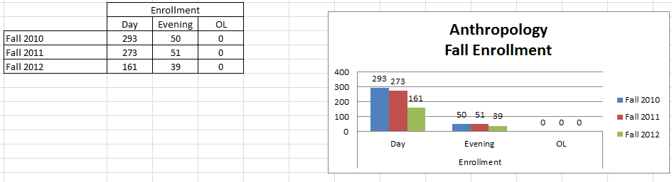

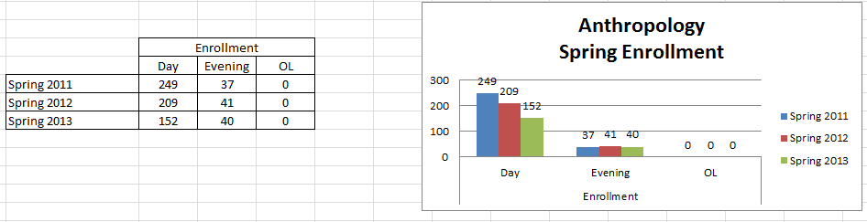

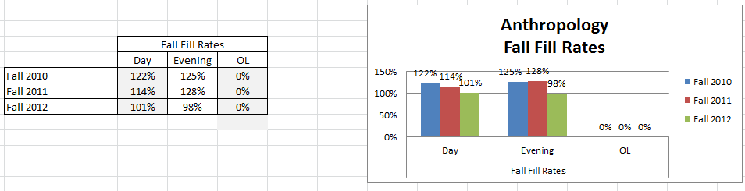

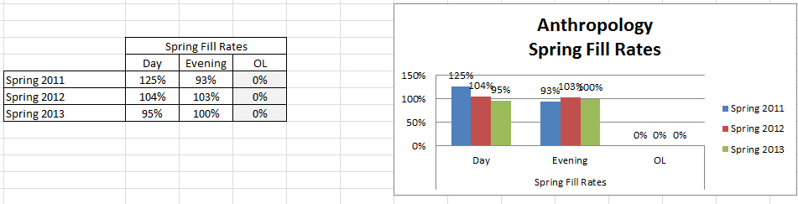

**Comments**: Day Enrollment dropped slightly in each semester from Fall 2010 to Spring 2013; going from 293 to 152. But Evening Enrollment while dropping from 50 to 40 showed more variation up and down during the period. The charts give a better picture of the changes. There were no online classes offered during the period.

Day Fill Rates followed the same trends as Day Enrollment, dropping slightly in each semester. They range from 125% to 96 in the Day. Most of the rates are above 100% with only 3 semesters in the 90s. So while enrollment has dropped over the period fill rates remain high. Enrollment management has helped increase overall results for the College but some of the block scheduling currently allocated to the Departments has limited options and requires Departments to determine which classes, based on available data, meets students’ needs best and best promotes student success.

1. What are the trends in productivity? (WSCH/FTEF) The goal is 525 as per state guidelines. A low number means that we are below target levels for productivity. For example, in a small class that has a mandated cap of 15 students, the fill rate may be 100% but the productivity number (WSCH/FTEF) will be very low. A class with a cap of 40 students with a 100% fill rate will have a productivity number close to or above 525.

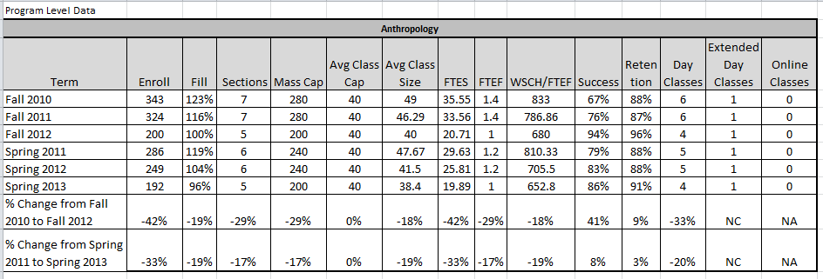

**Comments**: Productivity for this period is very high but is showing a downward trend. The productivity ranges from 833 down to 652—all of which are well above the 525 benchmark. This department continues to maintain high productivity.

1. Discuss and chart the success and retention rates by day, evening (extended day), and online classes in each program and identify gaps.

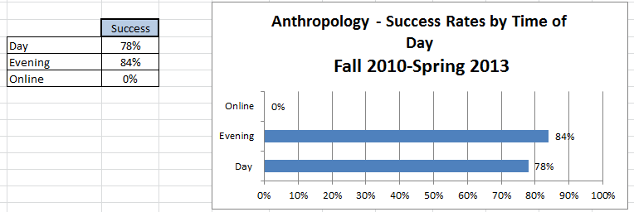

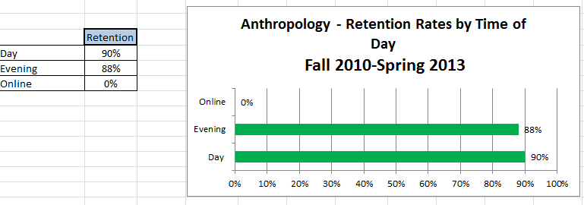

**Comments**: As illustrated by the charts Evening classes have a higher success rate 84 to 78 percent while Day classes have a slight edge in Retention, 90 to 88 percent. Both of these are solid numbers for Anthropology.

1. Discuss and chart the success and retention rates in each program and identify gaps for five ethnic groups. (African-American, White, all Hispanics, Other, Unknown).

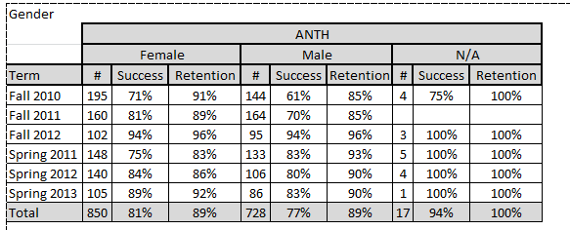

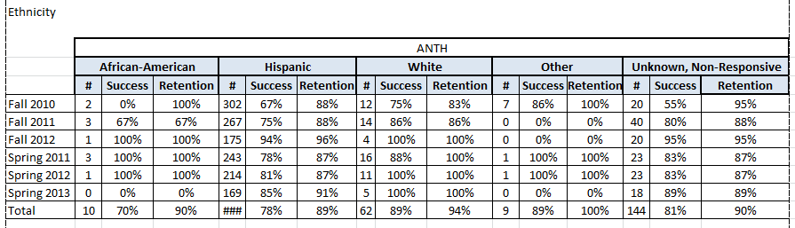

**Comments**: Females continue the national and state trend of being more successful than their gender counterpart by a margin of 81 to 77 percent. Retention rates were the same over the period.  
In order of success White led with 89%, then the Unknown with 81%, followed by Hispanic at 78%, and African-American with 70%. Retention followed the same pattern except for Hispanic and African-American—they were close with African-American ahead by a percentage point—90 to 89. These numbers indicated that more needs to be done to improve the success and retention of Hispanic and African-American students. The picture is a little confusing in that the Unknown category has the most students in it yet many of them could realistically belong to White, Hispanic, or African-American which would affect these rates. And, African-American has a small amount of students.

1. Discuss the trends in the number of degrees or certificates awarded, if applicable. (You may be able to expand more about this in B.3 below.)

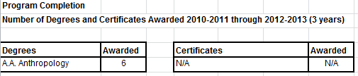

**Comments**: This statistic reveals a weakness in the program. A greater effort by instructors and Counseling to promote this degree is necessary. On a positive note the 6 degrees **doubles** the amount awarded in the last Program Review.

1. What program changes, if any, will you recommend that you expect would have a positive effect on your students in your program, if applicable?

**Comments**: Field trips to Museums or visiting sites with Anthropological significance would broaden student awareness and interest. Having more Native American artifacts would help students to understand the historical development and cultural significance of local Native American people. Obtaining more skeletal remains for classroom comparisons would also be helpful. For example, acquiring a chimpanzee skeleton so students could physically (hand-on) compare it with a human one.

1. Summarize revisions, additions, deletions, or alternate delivery methods to courses and/or program based on the last program review.

**Comments**: Instructor has added new, state-of-the art videos for more relevant content. New, contemporary, research from scientific magazines and quarterly journals are added each semester to keep students current in the field. SLO assessments continue to affirm that class attendance is vital to success.

1. Evaluate the program’s viability by addressing program completion, size (FTES), projections (growing/stable/declining), and quality of outcomes. For CTE programs, also include labor market projections, placement, and performance on external testing/exams (i.e. ASE, NABCEP) and industry-recognized credentials, placement, and performance on external testing or exams (NCLEX, ASC, NAP).

**Comments**: This program is stable and capable of growth. Though the completions are few they actually doubled from the last review. With the new ADT and with efforts to increase awareness and promote the degree completions should improve. Success and Retention rates have slightly decreased over the review period they show signs of improvement. Instructor is interested in creating a Physical Anthropology lab in the future.**C. FUTURE – LIST OF “SMART” (SPECIFIC** **MEASURABLE ATTAINABLE RELEVANT** **TIME-LIMITED) PROGRAM OBJECTIVES FOR NEXT ACADEMIC YEAR TO ADDRESS PROGRAM IMPROVEMENT, GROWTH, OR UNMET NEEDS/GOALS. ALL PROGRAM GOALS MUST ADDRESS AT LEAST ONE OF THE INSTITUTIONAL GOALS.**

|  |  |  |  |  |  |
| --- | --- | --- | --- | --- | --- |
| **FUTURE PROGRAM GOALS**  (Describe future program goals. List in order of budget priority.) | | | | | **INSTITUTIONAL GOAL(S)**  (Check all that apply.) |
|  | | | | |  |
| **1** | **FUTURE PROGRAM GOAL #1**  Budget Priority #1 | | | | **INSTITUTIONAL GOAL(S)** |
| **Identify Goal:** Provide online and/or hybrid classes to augment face-to-face instruction. | | | | | 1  2  3  4 |
| **Objective:** Develop “core” Anthropology online/hybrid classes that meet all requirements and provide students with an alternate delivery method. | | | | |
| **Task(s):** Identify faculty to develop the course or identify faculty from other colleges willing to teach online for us. Once identified, the course will have to be submitted to our Distance Education Department to assure compliance with all standards adopted by IVC. | | | | |
| **Timeline:** 2014-2015 Academic year | | | | |
| **EXPENSE TYPE** | | **FUNDING TYPE** | | **RESOURCE PLAN**  (Check all that apply.) | **BUDGET REQUEST** |
| One-Time  Recurring | | Categorical  Specify: | General Fund | Facilities  Marketing  Technology  Professional Development  Staffing | $0 |
|  | | | | |  |
| **2** | **FUTURE PROGRAM GOAL #2**  Budget Priority #2 | | | | **INSTITUTIONAL GOAL(S)** |
| **Identify Goal:** Increase the number of degrees awarded. | | | | | 1  2  3  4 |
| **Objective:** Expand student awareness about majoring in Anthropology. | | | | |
| **Task(s):** Work with Marketing and Counseling, circulate flyers in the Library and around campus, broadcast on the marquee, and generally promote the career opportunities available to this major. | | | | |
| **Timeline:** 2014-2015 Academic year | | | | |
| **EXPENSE TYPE** | | **FUNDING TYPE** | | **RESOURCE PLAN**  (Check all that apply.) | **BUDGET REQUEST** |
| One-Time  Recurring | | Categorical  Specify: | General Fund | Facilities  Marketing  Technology  Professional Development  Staffing | $0 |

|  |  |  |  |  |  |
| --- | --- | --- | --- | --- | --- |
| **3** | **FUTURE PROGRAM GOAL #3**  Budget Priority #3 | | | | **INSTITUTIONAL GOAL(S)** |
| **Identify Goal:**  Increase the part-time pool of instructor (Past Goal #2). | | | | | 1  2  3  4 |
| **Objective:** This remains a significant challenge. Efforts did not produce an expanded pool. Revise plan to expand part-time faculty pool. | | | | |
| **Task(s):** Network with other Community Colleges to identify online Anthropology instructors; continue to work with Human Resources and Marketing to assist with expanding the search. | | | | |
| **Timeline:** 2014-2015 Academic year | | | | |
| **EXPENSE TYPE** | | **FUNDING TYPE** | | **RESOURCE PLAN**  (Check all that apply.) | **BUDGET REQUEST** |
| One-Time  Recurring | | Categorical  Specify: | General Fund | Facilities  Marketing  Technology  Professional Development  Staffing | $0 |
|  | | | | |  |
| **TOTAL BUDGET REQUEST** | | | | | $0 |

1. How will your enhanced budget request improve student success?

**Comments**: ***All three do not require additional funds***. They do require greater coordination of resources that are already available at the College. Providing online classes will offer students more flexibility to manage their schedules and provide the College with more classroom availability; and more teaching faculty will relieve the pressure on the two current instructors—one full-time and one half time faculty. These changes are intended to promote more interest in the program and strengthen the teaching pool and generate more major declarations and degree awards.

**III. INSTITUTIONAL STUDENT LEARNING OUTCOMES (ISLOs)**

|  |  |
| --- | --- |
| **ISLO 1** | COMMUNICATION SKILLS |
| **ISLO 2** | CRITICAL THINKING SKILLS |
| **ISLO 3** | PERSONAL RESPONSIBILITY |
| **ISLO 4** | INFORMATION LITERACY |
| **ISLO 5** | GLOBAL AWARENESS |

**IV. PROGRAM LEARNING OUTCOMES (PLOs)**

|  |  |  |  |  |
| --- | --- | --- | --- | --- |
| **PROGRAM LEARNING OUTCOMES**  (Describe learning outcomes.) | | | | **ISLO(S)**  [Link PLO to  appropriate ISLO(s).] |
|  |  | | |  |
| **PLO**  **1** | **PROGRAM LEARNING OUTCOME #1** | | | **ISLO(S)** |
| **Identify Program Outcome:** Analyze biological diversity. | | | ISLO 1  ISLO 2  ISLO 3  ISLO 4  ISLO 5 |
| **Measurable Outcome Summary:** | | |
| Met | Partially Met | Not Met |
| **Provide detail on any improvements/effectiveness and detail status on those not fully met:** | | |
|  |  | | |  |

|  |  |  |  |  |
| --- | --- | --- | --- | --- |
| **PLO**  **2** | **PROGRAM LEARNING OUTCOME #2** | | | **ISLO(S)** |
| **Identify Program Outcome:**  Analyze cultural diversity. | | | ISLO 1  ISLO 2  ISLO 3  ISLO 4  ISLO 5 |
| **Measurable Outcome Summary:** | | |
| Met | Partially Met | Not Met |
| **Provide detail on any improvements/effectiveness and detail status on those not fully met:** | | |
|  |  | | |  |
| **PLO**  **3** | **PROGRAM LEARNING OUTCOME #3** | | | **ISLO(S)** |
| **Identify Program Outcome:** Outline prehistory and early civilization on a global perspective. | | | ISLO 1  ISLO 2  ISLO 3  ISLO 4  ISLO 5 |
| **Measurable Outcome Summary:** | | |
| Met | Partially Met | Not Met |
| **Provide detail on any improvements/effectiveness and detail status on those not fully met:** | | |
|  |  | | |  |
| **\*\*\*\*\* ATTACH PLO/SLO GRID \*\*\*\*\*** | | | | |