Academic Program Review



|  |  |  |
| --- | --- | --- |
| **ACADEMIC YEAR** | 2013-2014 | Basic Skills  Transfer  Career Technical Education (CTE) |
| **PROGRAM** | Alcohol and Drug Studies (ADS) | |
| **DEPARTMENT** | Behavioral and Social Sciences | |
| **DIVISION** | Health and Sciences | |
| **SUBMITTER** | Kevin White, Department Chair | |

**I. INSTITUTIONAL GOALS**

|  |  |
| --- | --- |
| INSTITUTIONAL GOAL  **1** | **INSTITUTIONAL MISSION AND EFFECTIVENESS** – The College will maintain programs and services that focus on the mission of the College supported by data-driven assessments to measure student learning and student success. |
| INSTITUTIONAL GOAL  **2** | **STUDENT LEARNING PROGRAMS AND SERVICES** – The College will maintain instructional programs and services which support student success and the attainment of student educational goals. |
| INSTITUTIONAL GOAL  **3** | **RESOURCES** – The College will develop and manage human, technological, physical, and financial resources to effectively support the College mission and the campus learning environment. |
| INSTITUTIONAL GOAL  **4** | **LEADERSHIP AND GOVERNANCE** – The Board of Trustees and the Superintendent/President will establish policies that assure the quality, integrity, and effectiveness of student learning programs and services, and the financial stability of the institution. |

**II. PROGRAM GOALS**

1. **PAST – EVALUATION OF PREVIOUS CYCLE OBJECTIVES/PROGRAM GOALS (SET IN PREVIOUS YEAR)**

List your previous objectives/goals and associated Institutional Goals. All program goals must address at least one of the institutional goals.

|  |  |  |  |  |  |
| --- | --- | --- | --- | --- | --- |
| **PAST PROGRAM GOALS**  (Describe past program goals.) | | | | | **INSTITUTIONAL**  **GOAL(S)**  (Check all that apply.) |
|  | |  | | |  |
| **1** | **PAST PROGRAM GOAL #1** | | | | **INSTITUTIONAL GOAL(S)** |
| **Identify Program Goal from Last Program Review:** Develop and implement an Ethics class. | | | | 1  2  3  4 |
| Met | | Partially Met | Not Met |
| **Provide detail on any improvements/effectiveness and detail status on those not fully met:** | | | |
| **2** | **PAST PROGRAM GOAL #2** | | | | **INSTITUTIONAL GOAL(S)** |
| **Identify Program Goal from Last Program Review:** Expand the Media Resources Library and make resource materials available to the community-at-large. | | | | 1  2  3  4 |
| Met | | Partially Met | Not Met |
| **Provide detail on any improvements/effectiveness and detail status on those not fully met:** The Department purchased media resources that updated old VHS tapes to DVD formats, acquired new titles and expanded the scope of topics within the discipline. | | | |
|  |  | | | |  |
| **3** | **PAST PROGRAM GOAL #3** | | | | **INSTITUTIONAL GOAL(S)** |
| **Identify Program Goal from Last Program Review:** Establish and expand training opportunities in community based programs for students involved in the program. | | | | 1  2  3  4 |
| Met | | Partially Met | Not Met |
| **Provide detail on any improvements/effectiveness and detail status on those not fully met:** This is an ongoing goal. This is critical to the success of the program as many of the community-based programs are religious or 12-Step in design. The Coordinator of the program has arranged with Imperial County Behavioral Services to place interns in their program. | | | |

Comments: The addition of the Ethics class aligns our program with the certification requirements of the state.

1. **PRESENT – DATA ANALYSIS AND PROGRAM HEALTH**
2. Summarize and analyze all disaggregated data by day, evening, gender, ethnicity, and distance education regarding enrollments, fill rates, productivity, completion, success, retention, persistence, and transfer (complete a, b, & c). ***Attach graphs or trend data***.
3. Discuss and chart the trends in enrollment and fill rate for each program by day and evening at the program level.

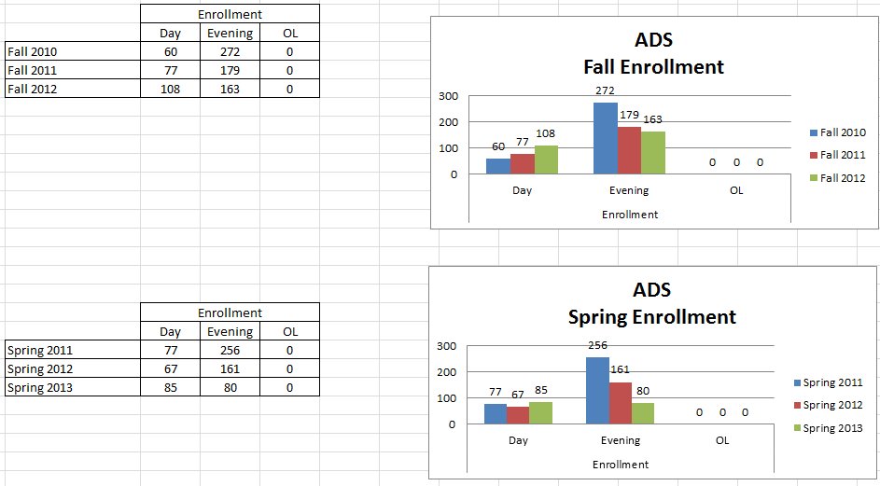

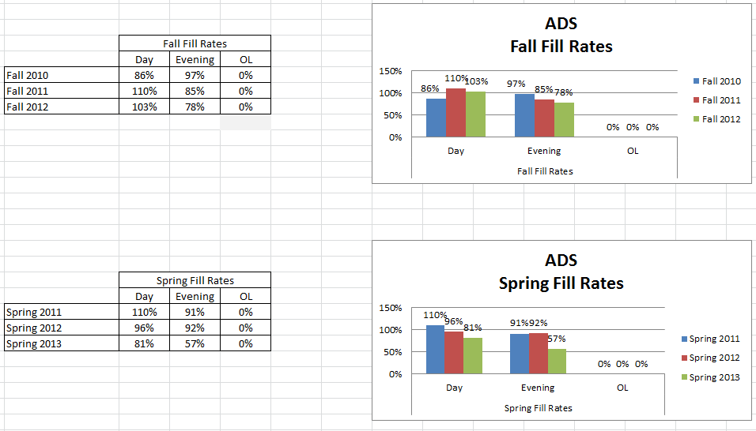

Enrollment in Fall and Spring grew by Day but decreased by Evening over the period. The drop in the Evening classes is a cause for concern as it has lost about two-thirds of its numbers—dropping from 256 to 80 students.   
Fill Rates were mixed over the period. Fall Day rates increased significantly while Evening showed a gradually decline.

1. What are the trends in productivity? (WSCH/FTEF) The goal is 525 as per state guidelines. A low number means that we are below target levels for productivity. For example, in a small class that has a mandated cap of 15 students, the fill rate may be 100% but the productivity number (WSCH/FTEF) will be very low. A class with a cap of 40 students with a 100% fill rate will have a productivity number close to or above 525.

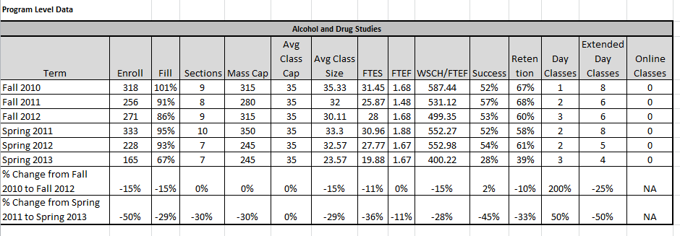

Productivity was above the marker of 525 except for Fall 2012 and Spring 2013 which were 499 and 400 respectively. This is in part due to the low enrollments and maintaining classes that are essential for graduation.

1. Discuss and chart the success and retention rates by day, evening (extended day), and online classes in each program and identify gaps.

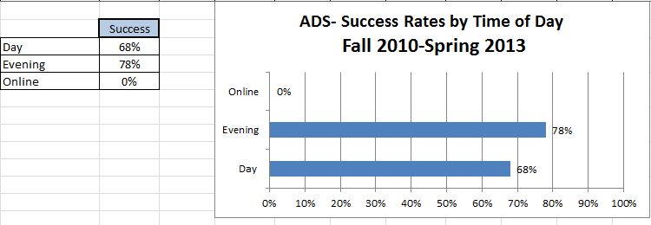

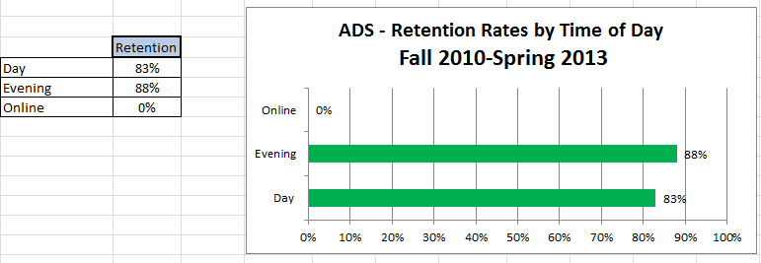

**Comments**: Evening classes have better success and retention rates than the Day classes. Yet the success and retention rates are stable and in line with IVC standards. There were no online classes offered during this period.

1. Discuss and chart the success and retention rates in each program and identify gaps for five ethnic groups. (African-American, White, all Hispanics, Other, Unknown).

|  |  |  |  |  |  |  |  |  |  |  |  |  |  |  |  |  |  |  |  |  |  |  |  |  |  |  |  |  |  |  |  |  |
| --- | --- | --- | --- | --- | --- | --- | --- | --- | --- | --- | --- | --- | --- | --- | --- | --- | --- | --- | --- | --- | --- | --- | --- | --- | --- | --- | --- | --- | --- | --- | --- | --- |
| Gender | | | |  | | |  | | | |  | | |  | | |  | | |  | | | |  | | |  | | |  | | |
|  | | | | ADS | | | | | | | | | | | | | | | | | | | | | | | | | | | | |
|  | | | | Female | | | | | | | | | | Male | | | | | | | | | | N/A | | | | | | | | |
| Term | | | | # | | | Success | | | | Retention | | | # | | | Success | | | Retention | | | | # | | | Success | | | Retention | | |
| Fall 2010 | | | | 219 | | | 70% | | | | 87% | | | 108 | | | 76% | | | 93% | | | | 5 | | | 100% | | | 100% | | |
| Fall 2011 | | | | 177 | | | 78% | | | | 88% | | | 78 | | | 72% | | | 87% | | | | 1 | | | 0% | | | 0% | | |
| Fall 2012 | | | | 189 | | | 76% | | | | 88% | | | 80 | | | 79% | | | 90% | | | | 2 | | | 100% | | | 100% | | |
| Spring 2011 | | | | 216 | | | 76% | | | | 85% | | | 115 | | | 77% | | | 85% | | | | 2 | | | 50% | | | 50% | | |
| Spring 2012 | | | | 159 | | | 82% | | | | 91% | | | 67 | | | 82% | | | 93% | | | | 2 | | | 100% | | | 100% | | |
| Spring 2013 | | | | 101 | | | 70% | | | | 78% | | | 63 | | | 46% | | | 63% | | | | 1 | | | 100% | | | 100% | | |
| Total | | | | 1061 | | | 75% | | | | 87% | | | 511 | | | 73% | | | 86% | | | | 13 | | | 85% | | | 85% | | |
| Ethnicity | | |  | |  | |  | | |  | | |  | | |  | | |  |  | | |  | | | |  | |  | | |  | | | |  |  | |  | |
|  | | |  | |  | |  | | |  | | |  | | |  | | |  |  | | |  | | | |  | |  | | |  | | | |  |  | |  | |
|  | | | ADS | | | | | | | | | | | | | | | | | | | | | | | | | | | | | | | | | | | | | |
|  | | | **African-American** | | | | | | | **Hispanic** | | | | | | | | | **White** | | | | | | | | **Other** | | | | | | | | | **Unknown, Non-Responsive** | | | | |
|  | | | **#** | | **Success** | | **Retention** | | | **#** | | | **Success** | | | **Retention** | | | **#** | **Success** | | | **Retention** | | | | **#** | | **Success** | | | **Retention** | | | | **#** | **Success** | | **Retention** | |
| Fall 2010 | | | 3 | | 100% | | 100% | | | 295 | | | 71% | | | 88% | | | 19 | 89% | | | 89% | | | | 3 | | 100% | | | 100% | | | | 12 | 75% | | 100% | |
| Fall 2011 | | | 4 | | 50% | | 50% | | | 208 | | | 75% | | | 87% | | | 20 | 90% | | | 95% | | | | 0 | | 0% | | | 0% | | | | 24 | 71% | | 92% | |
| Fall 2012 | | | 1 | | 100% | | 100% | | | 227 | | | 75% | | | 88% | | | 11 | 100% | | | 100% | | | | 0 | | 0% | | | 0% | | | | 32 | 81% | | 94% | |
| Spring 2011 | | | 4 | | 100% | | 100% | | | 283 | | | 76% | | | 85% | | | 23 | 87% | | | 91% | | | | 3 | | 67% | | | 67% | | | | 20 | 60% | | 70% | |
| Spring 2012 | | | 1 | | 100% | | 100% | | | 185 | | | 81% | | | 91% | | | 9 | 89% | | | 89% | | | | 2 | | 100% | | | 100% | | | | 31 | 87% | | 90% | |
| Spring 2013 | | | 3 | | 67% | | 67% | | | 145 | | | 61% | | | 71% | | | 3 | 100% | | | 100% | | | | 1 | | 100% | | | 100% | | | | 13 | 54% | | 85% | |
| Total | | | 16 | | 81% | | 81% | | | 1343 | | | 74% | | | 86% | | | 85 | 91% | | | 93% | | | | 9 | | 89% | | | 89% | | | | 132 | 74% | | 89% | |
|  | |  |  | | | |  | | |  | | |  | |  | | |  |  | | | |  | | |  |  | | | |  | | |  | |  | | |  | |
|  | |  |  | | | |  | | |  | | |  | |  | | |  |  | | | |  | | |  |  | | | |  | | |  | |  | | |  | |

**Comments**: There is only a slight difference between genders. Women are more successful while men have a slight edge in retention. The numbers African-Americans and Others are small and may be misleading when compared to the other groups. Regarding success in the program the order follows Whites, Others, African Americans, Hispanics, and Unknowns. The Unknown group has more members than African Americans, Whites, and Others combined yet it is almost impossible to identify members of this group for any type of follow up.   
Retention ranges from the 81 to 93 percent. These are good retention rates.

1. Discuss the trends in the number of degrees or certificates awarded, if applicable. (You may be able to expand more about this in B.3 below.)

|  |  |  |  |  |  |  |
| --- | --- | --- | --- | --- | --- | --- |
| **Program Completion** |  |  |  |  |  |  |
| **Number of Degrees and Certificates Awarded 2010-2011 through 2012-2013 (3 years)** | | | | | | |
|  |  |  |  |  |  |  |
| **Degrees** | **Awarded** |  | **Certificates** | | | **Awarded** |
| A.S. Alcohol & Drug Studies | 12 |  | Alcohol & Drug Studies | | | 13 |
|  |  |  |  |  |  |  |

**Comments**: This is an area of concern. As the program continues to grow and gain more exposure in the community the Degree and Certificates should increase. The program is an excellent complement to the religious and 12-Step programs in the Imperial Valley and it is beginning to provide some of the workforce needed to combat alcohol and drug abuse.

1. What program changes, if any, will you recommend that you expect would have a positive effect on your students in your program, if applicable?

**Comments**: Promote the 1 unit courses (176, 177, and 178) which are viewed as feeder classes for the program. And while many students pass through the program, greater efforts can be made to emphasis degree and certificate completions.

1. Summarize revisions, additions, deletions, or alternate delivery methods to courses and/or program based on the last program review.

The addition of the Ethics class to the curriculum has strengthened the program and aligned it more closely to state standards. Gaining internships at Behavioral Health has been a huge accomplishment and has opened the door to more training and placements for our students. These changes are generating greater interest and exposure of the program in the County.

1. Evaluate the program’s viability by addressing program completion, size (FTES), projections (growing/stable/declining), and quality of outcomes. For CTE programs, also include labor market projections, placement, and performance on external testing/exams (i.e. ASE, NABCEP) and industry-recognized credentials, placement, and performance on external testing or exams (NCLEX, ASC, NAP).

The program is stable and growing. Changes are being made based on data and assessment that are producing continuous program improvements. As stated earlier, greater community outreach for visibility and recruitment and efforts to encourage completions and the earning/granting of certificates are necessary to continue the growth of the program.

**C. FUTURE – LIST OF “SMART” (SPECIFIC** **MEASURABLE ATTAINABLE RELEVANT** **TIME-LIMITED) PROGRAM OBJECTIVES FOR NEXT ACADEMIC YEAR TO ADDRESS PROGRAM IMPROVEMENT, GROWTH, OR UNMET NEEDS/GOALS. ALL PROGRAM GOALS MUST ADDRESS AT LEAST ONE OF THE INSTITUTIONAL GOALS.**

|  |  |  |  |  |  |
| --- | --- | --- | --- | --- | --- |
| **FUTURE PROGRAM GOALS**  (Describe future program goals. List in order of budget priority.) | | | | | **INSTITUTIONAL GOAL(S)**  (Check all that apply.) |
|  | | | | |  |
| **1** | **FUTURE PROGRAM GOAL #1**  Budget Priority #1 | | | | **INSTITUTIONAL GOAL(S)** |
| **Identify Goal:** Expand the pool of part-time instructors | | | | | 1  2  3  4 |
| **Objective:** Provide enough qualified faculty (CADE approved) to teach all aspects of the program without overloading current faculty. | | | | |
| **Task(s):** Recruit through community based programs and community networking | | | | |
| **Timeline:** Academic year 2014-15 | | | | |
| **EXPENSE TYPE** | | **FUNDING TYPE** | | **RESOURCE PLAN**  (Check all that apply.) | **BUDGET REQUEST** |
| One-Time  Recurring | | Categorical  Specify: | General Fund | Facilities  Marketing  Technology  Professional Development  Staffing | $0 |
|  | | | | |  |

|  |  |  |  |  |  |
| --- | --- | --- | --- | --- | --- |
| **2** | **FUTURE PROGRAM GOAL #2**  Budget Priority #2 | | | | **INSTITUTIONAL GOAL(S)** |
| **Identify Goal:** Develop more community partnerships that lead to internships and employment. | | | | | 1  2  3  4 |
| **Objective:** Obtain more internships and placements within the local communities | | | | |
| **Task(s):** Network with current community partners and develop new partnerships to expand ADS’s community awareness and involvement as a viable resource. | | | | |
| **Timeline:** Academic year 2014-15 | | | | |
| **EXPENSE TYPE** | | **FUNDING TYPE** | | **RESOURCE PLAN**  (Check all that apply.) | **BUDGET REQUEST** |
| One-Time  Recurring | | Categorical  Specify: | General Fund | Facilities  Marketing  Technology  Professional Development  Staffing | $0 |

|  |  |  |  |  |  |
| --- | --- | --- | --- | --- | --- |
| **3** | **FUTURE PROGRAM GOAL #3**  Budget Priority #3 | | | | **INSTITUTIONAL GOAL(S)** |
| **Identify Goal:** To become a community resource for ADS media materials (especially DVDs) and speakers. | | | | | 1  2  3  4 |
| **Objective:** Provide cutting edge resources and speakers to community groups. | | | | |
| **Task(s):** Create a list of resource material and speakers list. | | | | |
| **Timeline:** Academic year 2014-15 | | | | |
| **EXPENSE TYPE** | | **FUNDING TYPE** | | **RESOURCE PLAN**  (Check all that apply.) | **BUDGET REQUEST** |
| One-Time  Recurring | | Categorical  Specify: | General Fund | Facilities  Marketing  Technology  Professional Development  Staffing | $0 |
|  | | | | |  |
| **TOTAL BUDGET REQUEST** | | | | | $0 |

1. How will your enhanced budget request improve student success?

These goals do not involve budget allocations.

**Comments**: The success of this program and the students involved in it is closed tied to community support. Creating more community partnerships and providing value media resources to the community will improve program exposure and assist in generating internships and placements. It is a reciprocal process furthers continuous program improvements and facilitates student success.

**III. INSTITUTIONAL STUDENT LEARNING OUTCOMES (ISLOs)**

|  |  |
| --- | --- |
| **ISLO 1** | COMMUNICATION SKILLS |
| **ISLO 2** | CRITICAL THINKING SKILLS |
| **ISLO 3** | PERSONAL RESPONSIBILITY |
| **ISLO 4** | INFORMATION LITERACY |
| **ISLO 5** | GLOBAL AWARENESS |

**IV. PROGRAM LEARNING OUTCOMES (PLOs)**

|  |  |  |  |  |
| --- | --- | --- | --- | --- |
| **PROGRAM LEARNING OUTCOMES**  (Describe learning outcomes.) | | | | **ISLO(S)**  [Link PLO to  appropriate ISLO(s).] |
|  |  | | |  |
| **PLO**  **1** | **PROGRAM LEARNING OUTCOME #1** | | | **ISLO(S)** |
| **Identify Program Outcome:** Demonstrate understanding of the physical and psychological disease of addiction. | | | ISLO 1  ISLO 2  ISLO 3  ISLO 4  ISLO 5 |
| **Measurable Outcome Summary:** | | |
| Met | Partially Met | Not Met |
| **Provide detail on any improvements/effectiveness and detail status on those not fully met:** | | |
|  |  | | |  |

|  |  |  |  |  |
| --- | --- | --- | --- | --- |
| **PLO**  **2** | **PROGRAM LEARNING OUTCOME #2** | | | **ISLO(S)** |
| **Identify Program Outcome:** Demonstrate an understanding of counseling theory used in addiction counseling. | | | ISLO 1  ISLO 2  ISLO 3  ISLO 4  ISLO 5 |
| **Measurable Outcome Summary:** | | |
| Met | Partially Met | Not Met |
| **Provide detail on any improvements/effectiveness and detail status on those not fully met:** | | |
|  |  | | |  |
| **PLO**  **3** | **PROGRAM LEARNING OUTCOME #3** | | | **ISLO(S)** |
| **Identify Program Outcome:** Demonstrate critical thinking and skills to intervene with an addict and the codependent family. | | | ISLO 1  ISLO 2  ISLO 3  ISLO 4  ISLO 5 |
| **Measurable Outcome Summary:** | | |
| Met | Partially Met | Not Met |
| **Provide detail on any improvements/effectiveness and detail status on those not fully met:** | | |
|  |  | | |  |
| **\*\*\*\*\* ATTACH PLO/SLO GRID \*\*\*\*\*** | | | | |