Touchnet
Insurance Premium Online Payment Guide

- There are three different ways to access the Touchnet platform.
- Visit the IVC Health and Wellness Benefits page at Imperial.edu, select Faculty & Staff, select Health & Wellness, select Touchnet Employee Online Premium payments.
- You can click on the following link and be directed to the Touchnet online payment store if you are not immediately directed to the webpage, hold the Ctrl key and click on link.
https://marketplace.imperial.edu
- Type https://marketplace.impeiral or copy and paste to your web browser

- Once you have reached the IVC Marketplace click on the “Benefits” thumbnail.



- Once you are on the Products page select the applicable thumbnail. There are two catagories to chose from, the Administrators, Classified, Faculty Non-Teaching, and Board Members group or the Faculty Teaching category
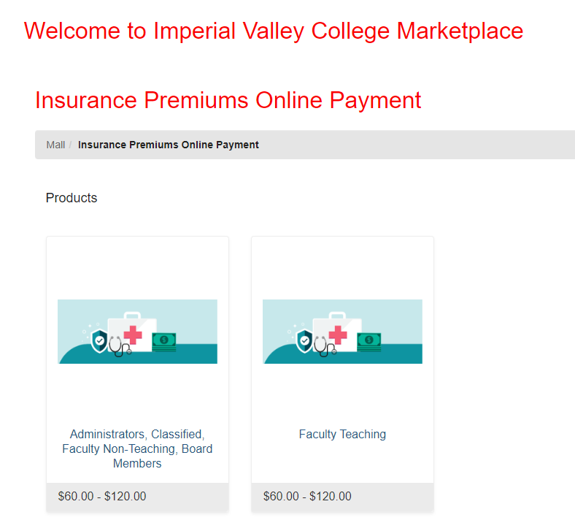

- Once on the Store screen select the applicable coverage and tier. Enter the quanity of months you would like to pay for and click on “Add To Cart”

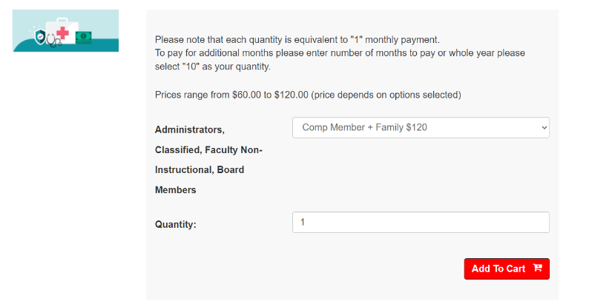
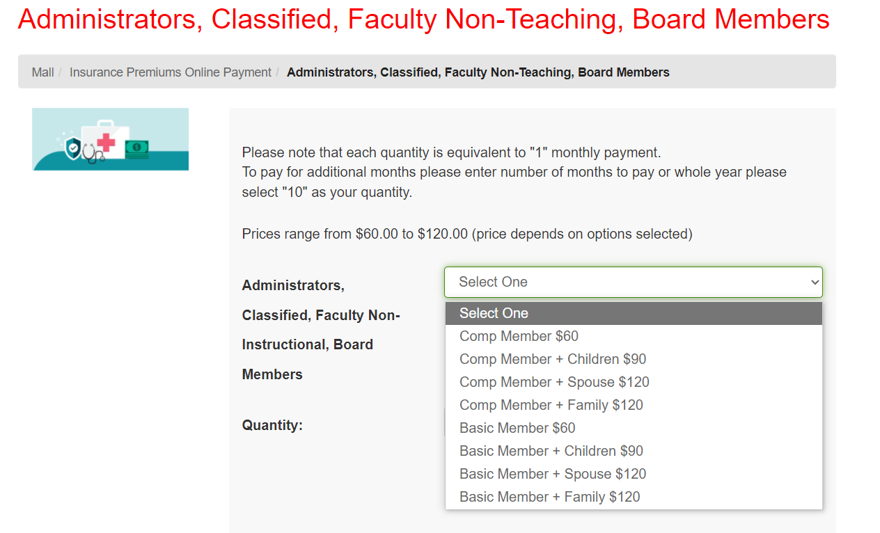

- Fill out your information and click “continue”
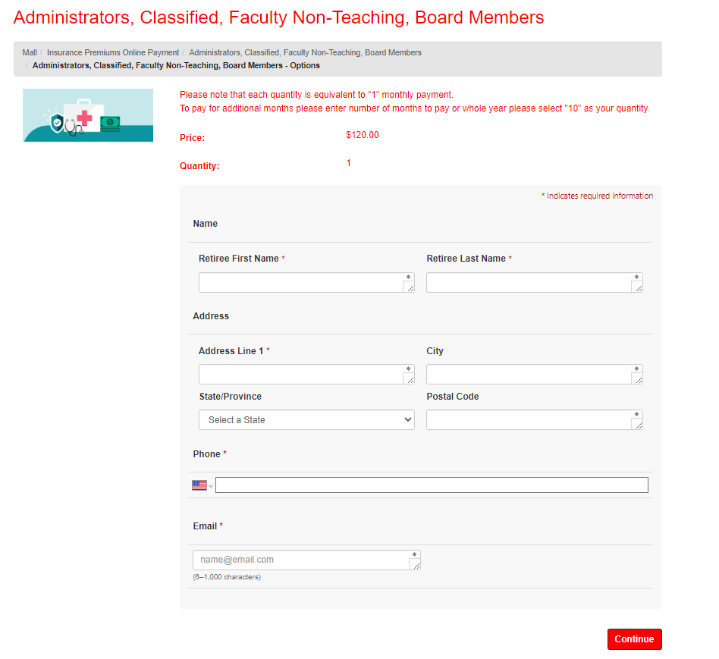

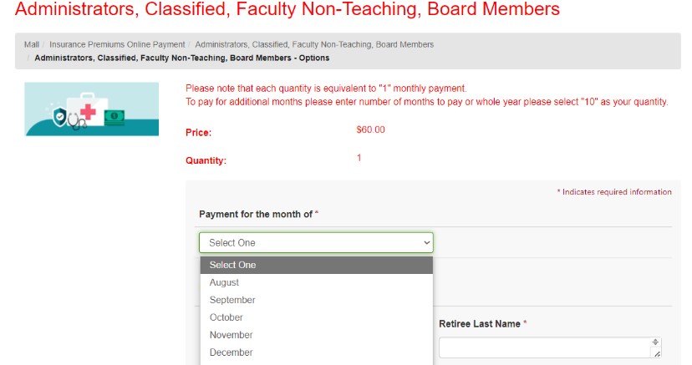

Select the month you are paying for

- Review your cart prior to checking out. Ensure your quantity and grand total are correct. Click “Checkout”
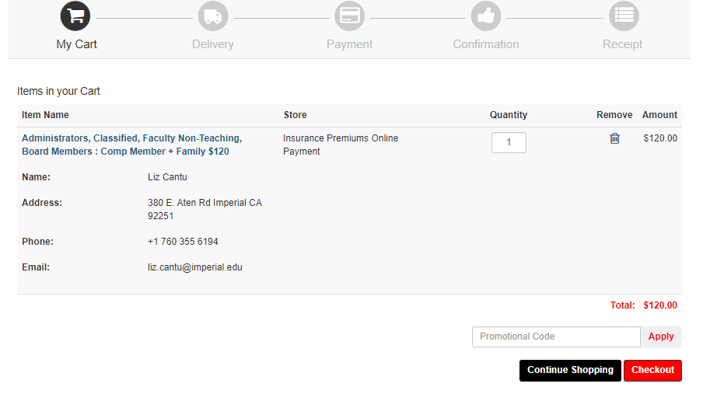

- If this is your first time using the Marketplace, you will need to register and create a password. After you have registered, you will only need to sign on with your Username and Password.

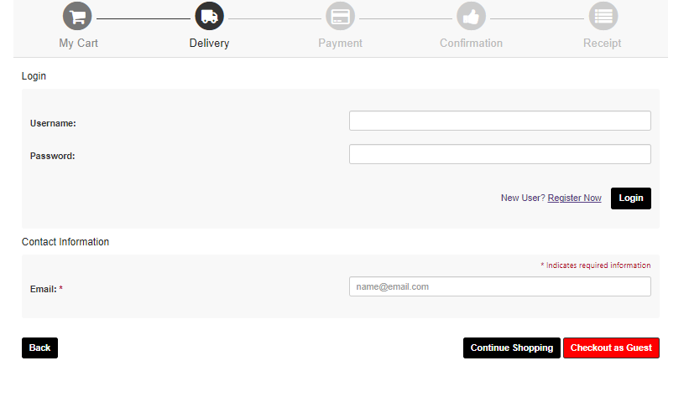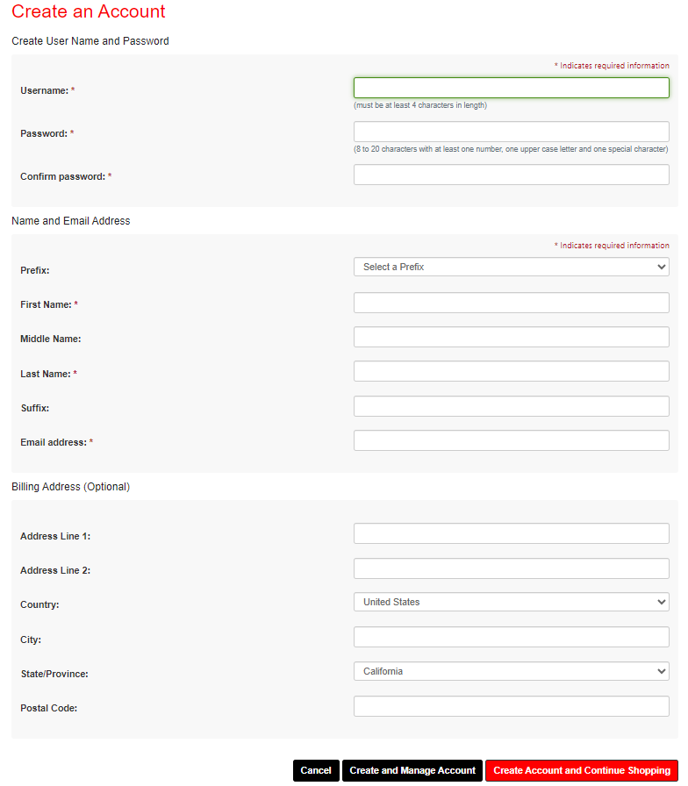

- Once you have registered you will be able to complete the payment screen. You may click on “save card to profile” for quicker future checkouts. After completing the payment information click on continue.
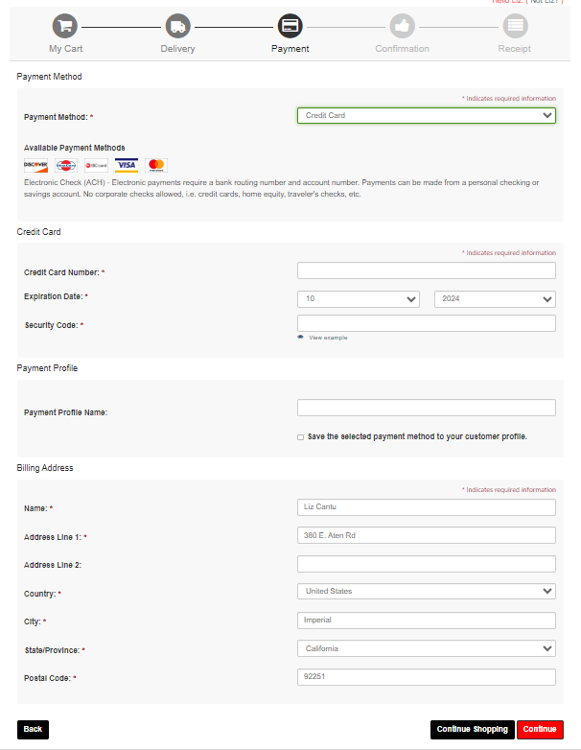

- Once you have confirmed your payment you will receive a digital receipt.
