# **Register for a LibreOne Instructor Account**

1. Go to [**one.libretexts.org/register**](http://one.libretexts.org/register) and enter your **email address and password**, then click “Create account” button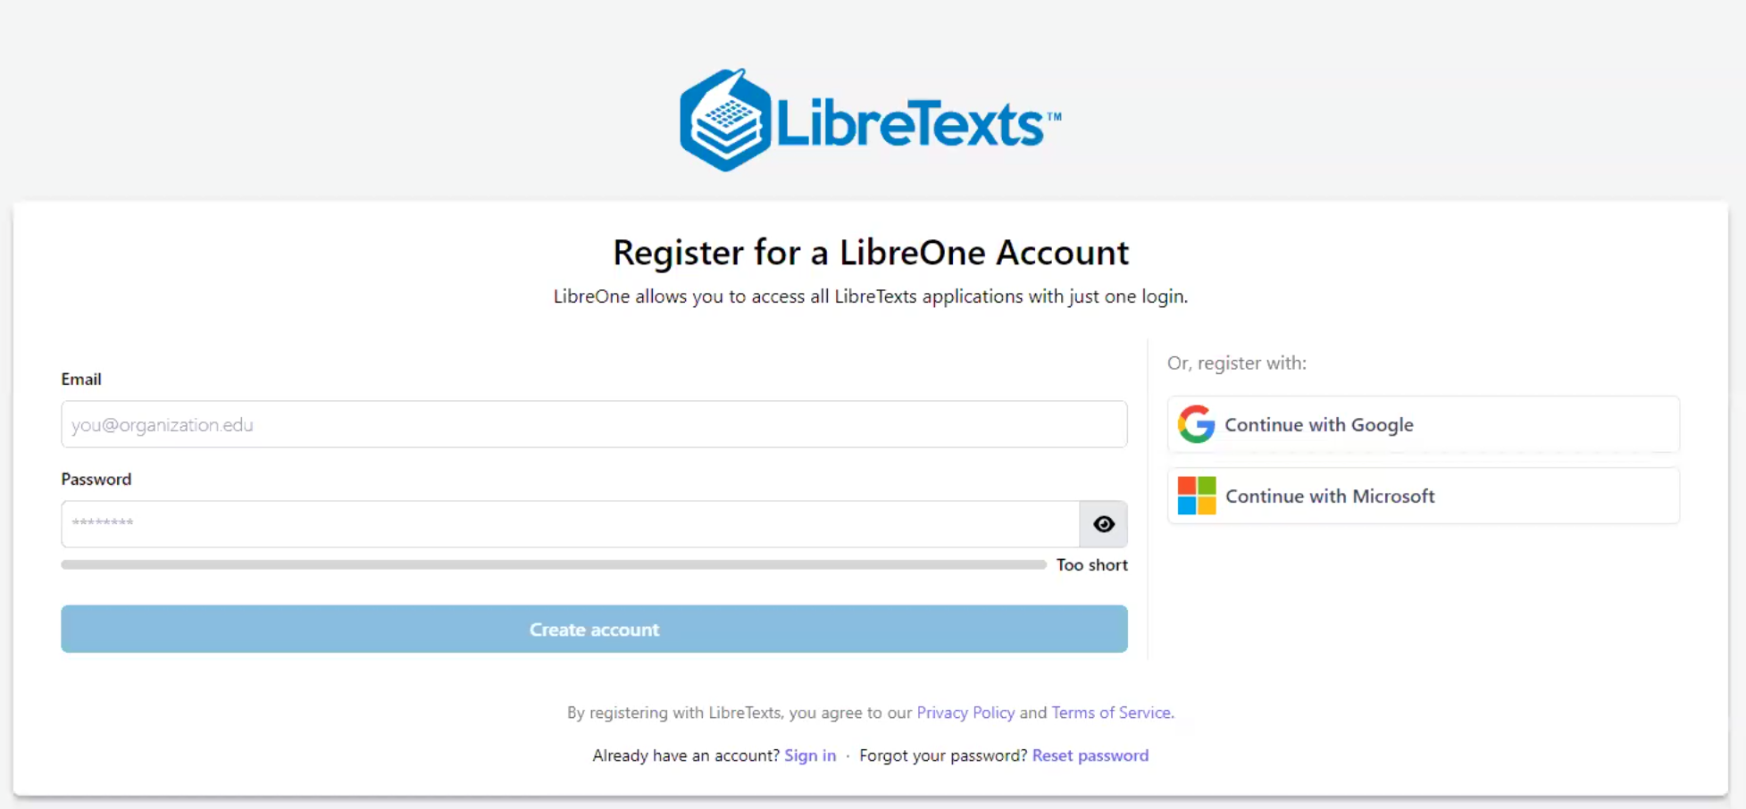
2. Enter the six-digit **confirmation code** sent to your email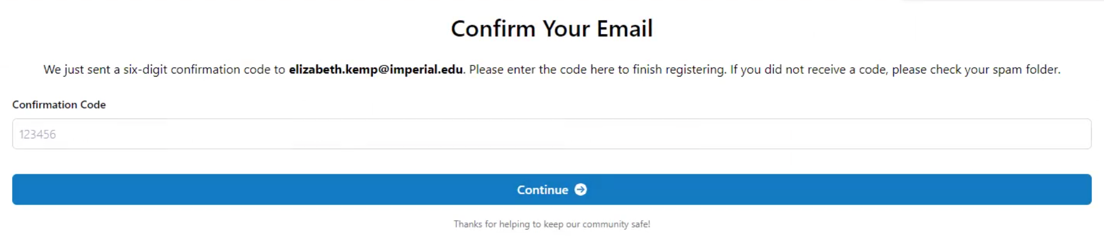
3. Answer questions about your preferred first and last name, then select “I’m an instructor” button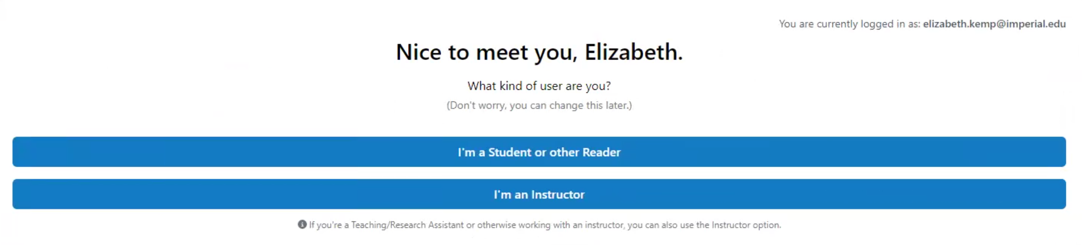
4. Select your institution (Imperial Valley College) and time zone, which completes your registration. To verify your instructor status to access educator-only services, click “Continue to Instructor Verification” button, then “Start Verification Request” button.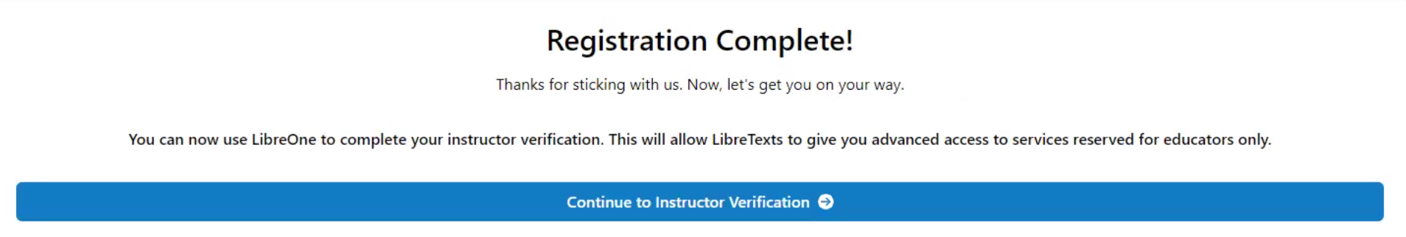
5. To confirm your status as an active instructor, you’ll need to enter a link into the “Bio URL” field. 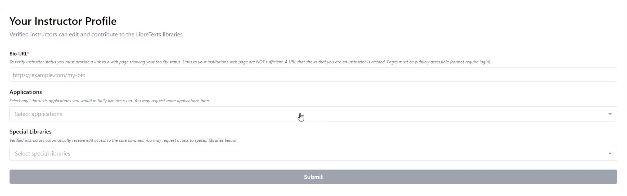

To get a URL that points directly to you and your courses in the IVC schedule, open a new tab and go to [**schedule.imperial.edu**](https://schedule.imperial.edu/) and click “Advanced Search.” Find **your name** in the “Instructors” pull-down menu and click the **red “Submit” button.**

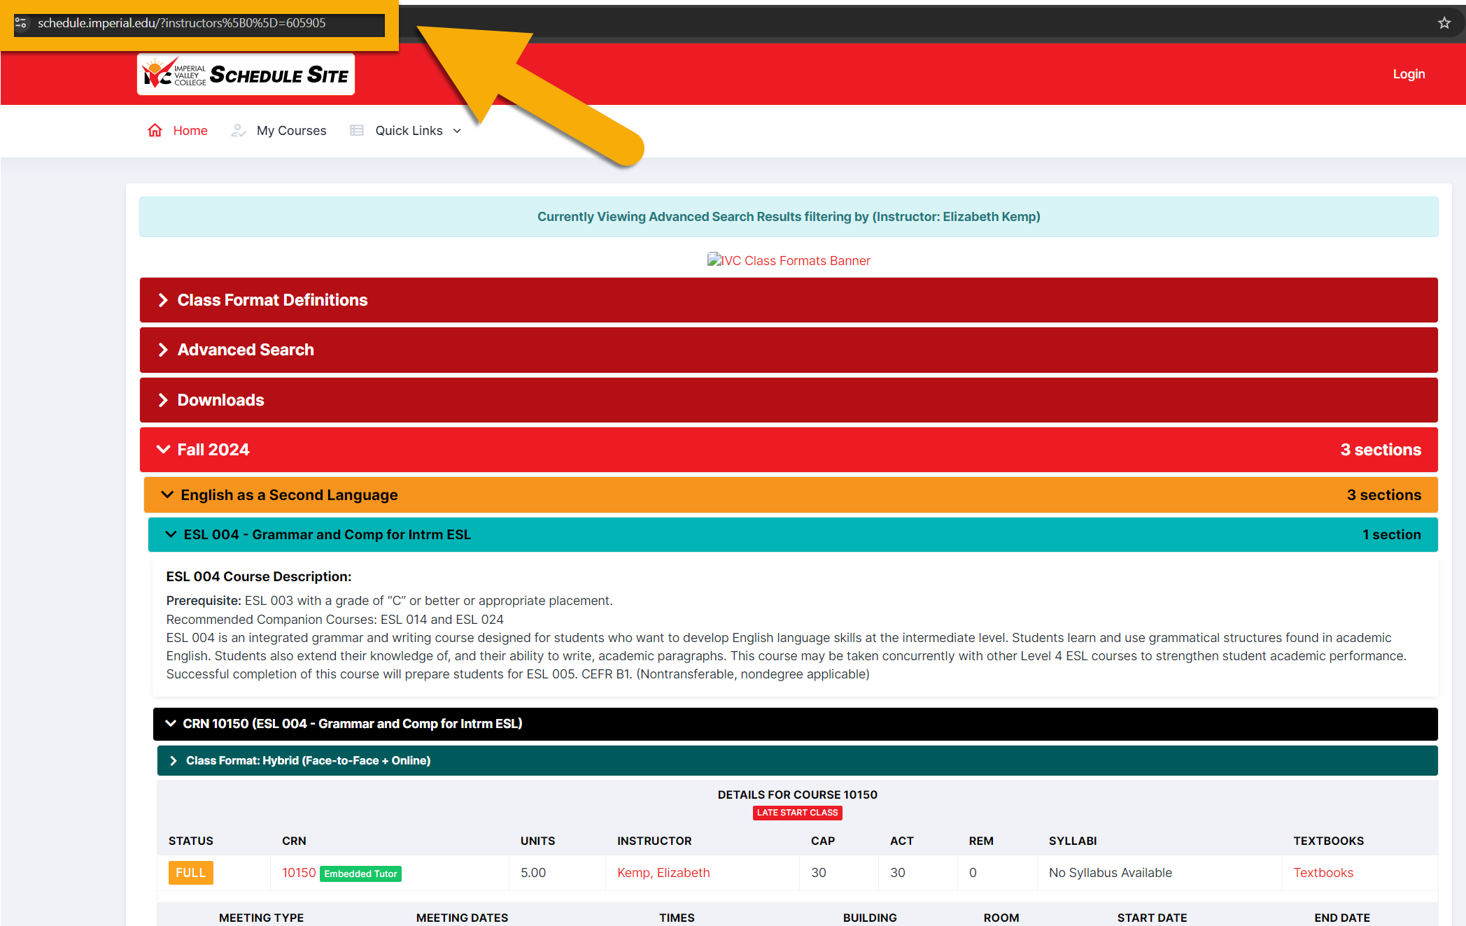  
The **resulting URL** (here, <https://schedule.imperial.edu/?instructors%5B0%5D=605905>)

in the navigation bar of your browser will lead directly to **your own schedule of courses taught**. Copy and paste it into the “Bio URL“ field, and **click the blue “Submit” button** to submit.

1. Watch your email for official verification of your instructor status, which may take up to 48 hours.